
Birding Trip Report

Central and North Chile
with Juan Fernandez island
October 8th to 12th, December 4th to 17th, 2006

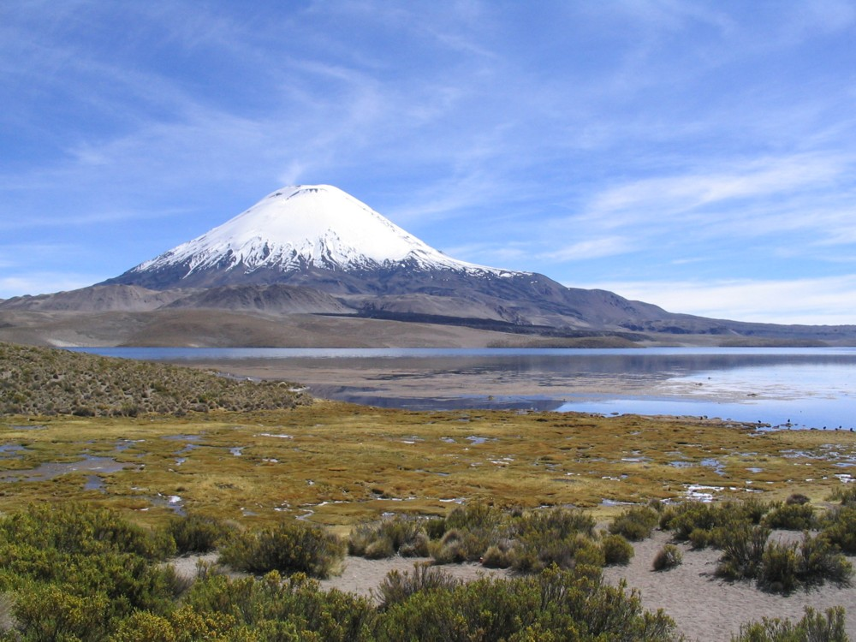

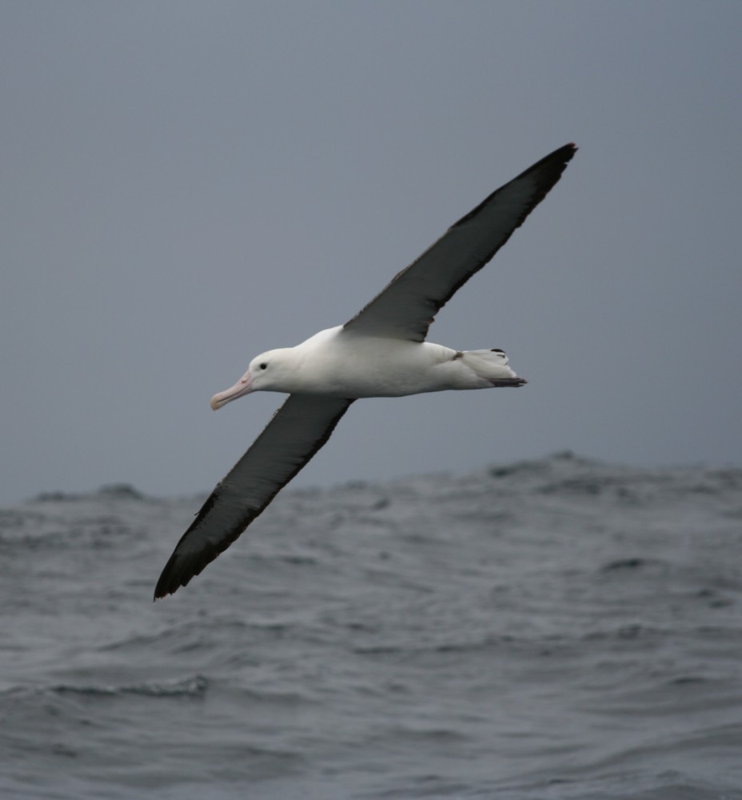

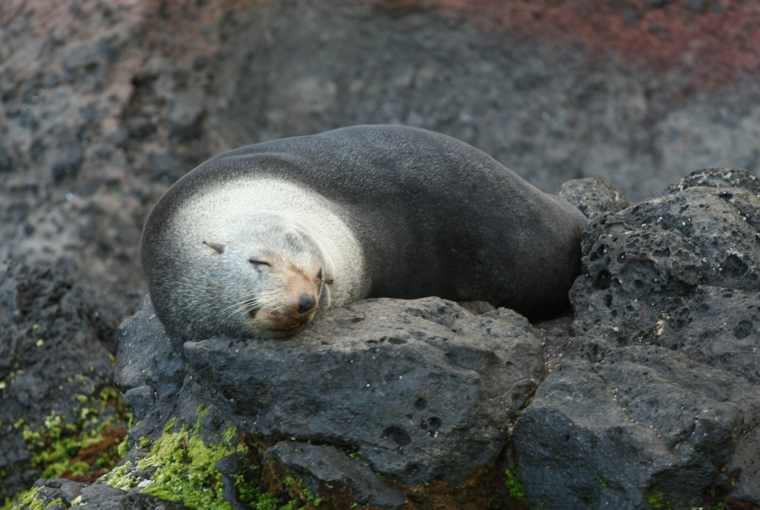

Leader, trip redaction : Fabrice Schmitt
Participants : Skyp and Lyn Nelson, Jay Lamb (December 4th to 17th)
Steve Huggins (December 8th to 17th)
Driver : Julio Benites

While guiding a Kolibri Expeditions 'Central Peru Trip' I had one of most incredible experiences of my life getting to guide for the world famous Skip Nelson and his beautiful wife Lyn in October of 2005.

Skip and Lyn decided to come back to South America in 2006/07for a 6 month trip which included Ecuador, Peru, Bolivia, Argentina and Chile. As I'm living in Chile and am well acquainted with the birds of Argentina and Chile, they kindly asked me if I would like to guide them for the Chile-Argentina part of their trip... of course, I immediately accepted !!

Let's go for a 70 day trip via the northern Chilean desert, Argentinean altiplano, pampas, tropical forest, sea shores, Patagonian scrubs, glaciers, Chilean fjords, etc...
Seventy days full of birds, birds, and birds, but also incredible mammals and landscapes !
Seventy days of great wine, wonderful barbecue, seafood, even lemon liquor with Hoy's Screech-owl singing in the garden of the hotel, ... and of course, peanut butter !! (I guess Skip could not survive 2 weeks without peanut butter, and after this trip, I'm almost addicted…)
Seventy days during which Skip and Lyn where obliged to enjoy my French accent...

This trip report only represents one part of the whole trip : "Chile with Juan Fernandez island"

Many of the Chilean species were also seen during the North-west Argentina and Patagonian portion of the complete trip.
If you want to have a complete look at our 70 day trip, please read :

- "North-West of Argentina, October 13th to 29th"
- "Few days in the North-east of Argentina, October 31st to November 6th"
- "Patagonia, November 9th to 30th"

If you are interested in a trip in Chile, Argentina or Peru, don't hesitate to contact me : fabrschmitt@yahoo.com.ar

Itinerary

October 7th – Rendez-vous in La Paz !
Fabrice flew from Santiago (Chile) to La Paz (Bolivia).
Skip, Lyn and Gunnar Engblom (Kolibri Expeditions's manager) drove from Inquisivi (where they saw the endemic Spinetail) to La Paz. Skip and Lyn just completed a one month trip with Kolibri Expeditions in Bolivia, during which they saw all their target birds !!

October 8th
Mainly a driving day, from La Paz to Putre (Chile).
Just before the Chilean border, after a late lunch, Lyn found 3 Puna Tinamou... birds of the day !
We managed few selected stops to see some altiplano species even if Skip and Lyn already saw most of them, and arrived at Putre at 7 pm.

October 9th
Some birding before breakfast... just enough for Skip to find an American Redstart... 4th record for Chile !! Well done Skip and thank you for this tick !
After good views of White-throated and Plain-breasted Earthcreeper, Canyon Canastero, Spot-winged Pigeon, Blue-and-yellow Tanager and other species restricted in Chile to the north of the country, we drove to the Chapiquiña Polylepis woodland, where we rapidly found 2 Thick-billed Siskin, 1 Giant Conebill and 1 Rufous-webbed Tyrant... time for Skip and Lyn to add a few new ticks !
Night in Arica

October 10th
Early morning in the Azapa valley with a breakfast in the Hummingbird Paradise managed by the Madrid family. Lot's of Oasis Hummingbird and Peruvian Sheartail, but impossible to find the hummingbird we are looking for, the endemic and endangered Chilean Woodstar. So we decided to go to the Chaca valley where we saw 2 males displaying !
Back to Arica, we prospected the rocky shore and the Lluta mouth where we saw some rare species for Chile : Spotted, Least and Semipalmated Sandpiper, Little Blue Heron and one endemic species, the Chilean Seaside Cinclodes.
Night in Arica.

October 11th
Early breakfast in the Camarones valley where we had a beautiful view of a Magellanic Horned Owl. We then drove to the "Pampas de los Tamarugales" to see the Tamarugo Conebill which we got while drinking pineaple juice !
After a successful morning, we made our way to the south, and reached San Pedro de Atacama in the late afternoon, after a very long, but beautiful drive in this desolate landscape.
Night in San Pedro de Atacama.

October 12th
Wake up at 4 am to reach the Tatio geyser area. Taking some pictures of the geysers in the sunrise, we easily found 2 Red-backed Sierra-finches acclimated to the many tourists taking their breakfast.
Floggin' the main target of the morning , we drove to the Miscanti lagoon where the Horned Coot, a very localised Andean species, is common.
On the way, we also saw 4 Greyish Miners and an Aplomado Falcon.
Night in San Pedro de Atacama.

From October 13th to December 4th, almost 2 months birding trip in most of Argentina and the extreme south of Chile (see the 3 others trip reports).

In the evening of November 30th, Lyn, Skip and Jay (a third birder arrived for the Patagonian and South/Central Chile part of the trip), took the Navimag ferry boat from Puerto Natales (southern Chile). They sailed 3 full days along the Chilean coast to reach Puerto Montt where Julio and Fabrice met up with them again.
These 3 days through the fjords and the patagonian coast are impressive. Contemplating the amazing landscapes, glaciers, forests or the few Black-browed Albatroses always present behind the boat, we should not forget that we are crossing Alakalufe country.... though they disappeared a few decades ago, their spirit still haunts these mist shrouded shores !!

December 4th
Julio and Fabrice were a little bit late at the rendez-vous in Puerto Montt: the minibus broke an axe in Punta Arenas, and it took one day and a half to repair it.
We then drove to Maullin where we found a flock of Slender-billed Parakeets, but as the view where pretty poor, we decided to wait close to another parakeet roost found by Fabrice last year. It was here that we were rewarded with better views of several birds arriving in the late afternoon.
In Maullin, Jay found a pair of Saffron Finch: a nice range extension for this species in Chile.
We arrived by night at the Caullin Bay lodge, on the Chiloe island, where we spend the night.
Skip, a seafood lover, was quite happy that night with his 3 plates of chilean oysters and two bottles of wonderful chilled Chilean white wine to compliment the bivalves !

December 5th
While birding along the Caullin Bay, where hundreds or thousands of shorebirds and gulls occur, we were witness to the harvesting of the seagrasses by the local people a fantastic visual experience.
We then drove back to the continent to reach the Alerce Andino NP.
There, we easily found the Ochre-flanked Tapaculo, the Chucao Tapaculo and the Black-throated Huet-huet, and the Des Mur's Wiretail... a ping-pong ball with a tail.
During a night walk around our campsite, we spoted a Rufous-legged Owl calling on a dead stick.

December 6th
Birding in the Alerce Andino NP in the morning, and then a long drive to Victoria where we spend the night.

December 7th
In the morning, we spend few hours in the Nahuelbuta NP, where we had good views of a pair of Patagonian Tyrant.
A White-throated Hawk was soaring with 2 Red-backed Hawk, but we dipped on the expected Rufous-tailed Hawk...
In the afternoon, we drove to Chillan and the mountains around Termas de Chillan, an excellent place to look for and find the Chestnut-throated Huet-huet. The Des Mur's Wiretail was also an easy target here !!

December 8th
After some birding around the Termas de Chillan, we drove to the Lampa wetlands, close to Santiago. There, we met Steve Huggins coming from Chicago, and Rodrigo his Chilean guide/driver for the day.
Rodrigo recently found in this marsh a Long-winged Harrier, not seen in Chile since almost 50 years, but the vagrant bird disappeared two days before we arrived in Lampa....
But the true specialities here are the South American Painted-snipe, and the Chilean form of the Warbling Doradito (a probable forthcoming split).
We saw both of them as well as a few more wetland species, and then drove to Concon, on the Pacific coast.

December 9th.
Pelagic trip from Quintero, with good views of some Humboldt current specialities.
Night in Santiago.

December 10th
We birded the Mahuida private park in the morning, where we saw lot's of the central Chile endemics: Dusky Canastero, Moustached Turca, White-throated Tapaculo, Chilean Mockingbird... even 2 Chilean Tinamou were flushed !!
We spend the rest of the day in the high mountains, mainly close to the sky resort of Farellones.
The main target, the Crag Chilia was seen very well, as well as some other specialities such as White-sided Hillstar, Creamy-rumped Miner, the highland form of Magellanic Tapaculo, and of course the Andean Condor.
In the afternoon, we birded the Batuco wetlands.

December 11th
Another day in the highlands.
The target of the day was the Diademed Sandpiper-plover, and we had excellent views on 4 different birds.
Cordilleran Canastero, Scale-throated Earthcreeper, and Greater Yellow-finch were also seen this day.

December 12th to 17th
Morning flight to the Juan Fernandez Island.
During the boat trip from the airport to the small town of San Juan Bautista, we found a few Kermadec Petrels and several Pink-footed Shearwaters.
In the afternoon, we easily found the amazing Juan Fernandez Firecrown and the Juan Fernandez Tit-tyrant, the two endemic land-birds of the island.
Unfortunately, the community lobster fishing boat did not arrive until evening of the 13th. Then the bad weather prognostics would not allow us to go on Selkirk... so we missed out on our chance for the Rayadito.
Anyway, during a short pelagic trip from Juan Fernandez, we did manage to add the White-bellied Storm-petrel and the Juan Fernandez Petrel to our list. During a short hike to the top of the island Lyn found a Masafuera Hawk and photographed by Steve Huggins. This endemic breeder to Selkirk, is sometimes crossing the 180 km between Selkirk and Juan Fernandez islands… felicitation Lyn !
Some Pictures

All these pictures are from Steve Huggins and have been done during this trip.
If you want to see more Steve's pictures, have a look at http://www.pbase.com/sjhuggins/root
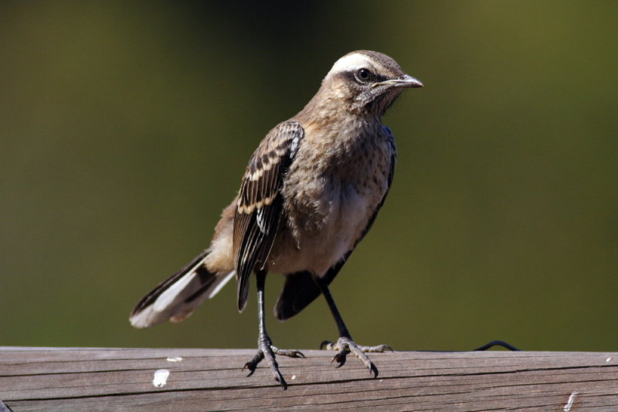
Chilean Mockingbird
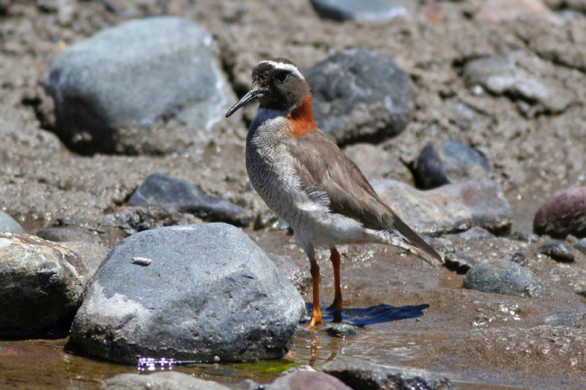
Diademed Plover

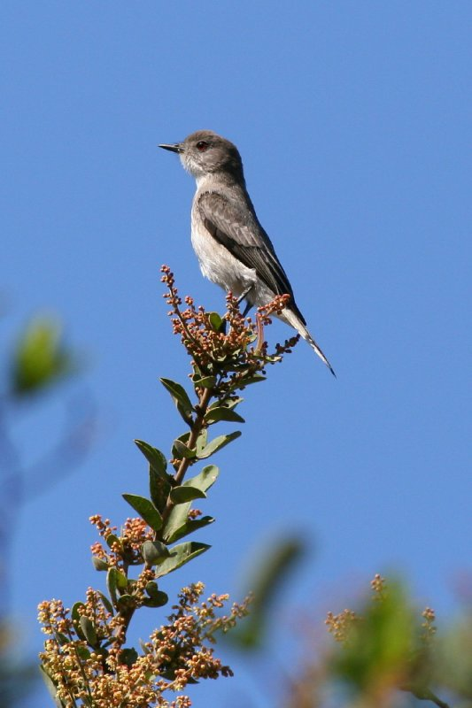
Fire-eyed Diucon
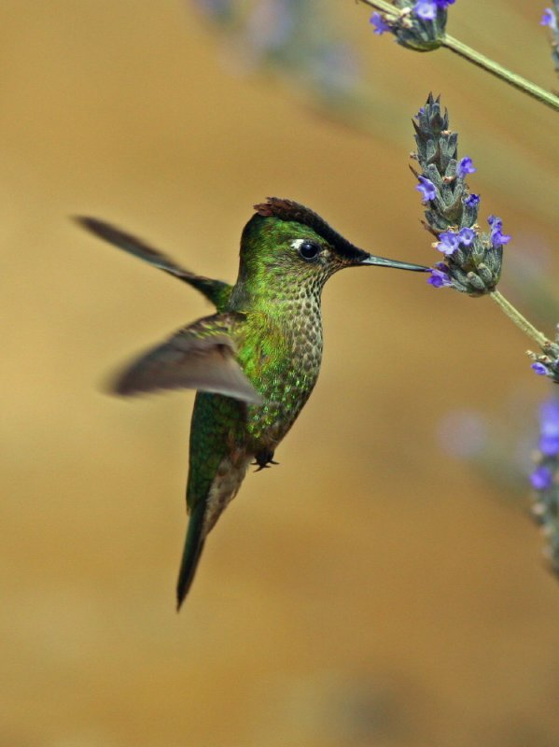
Green-backed Firecrown
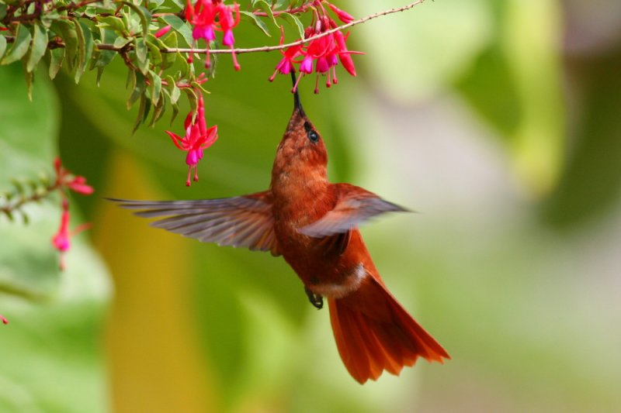
Juan-Fernandez Firecrown
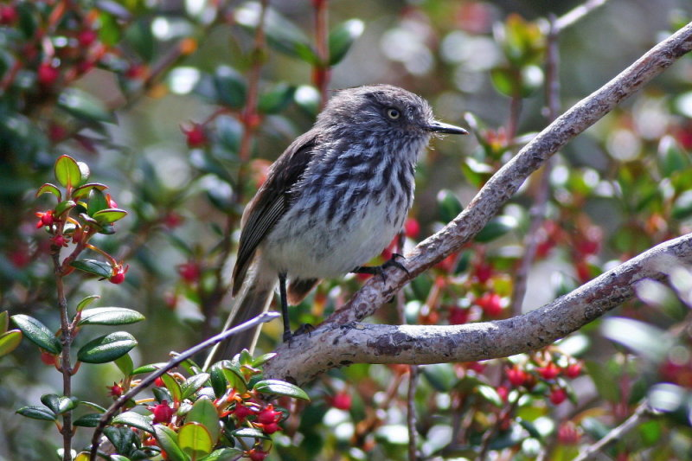
Juan-Fernandez Tit-tyrant
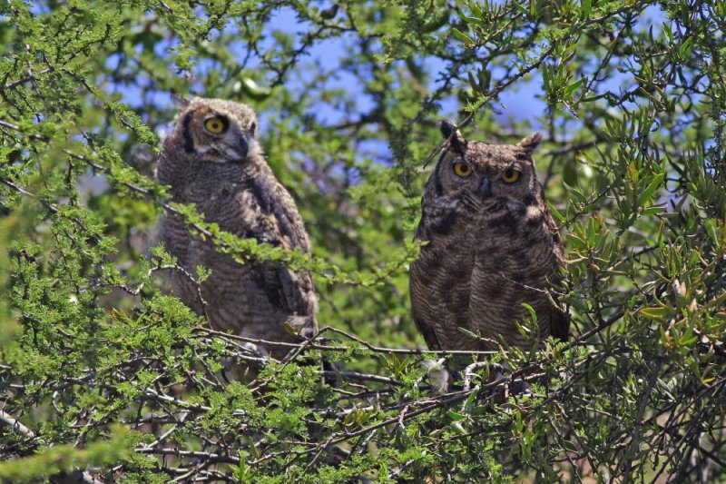
Magellanic Horned-owl
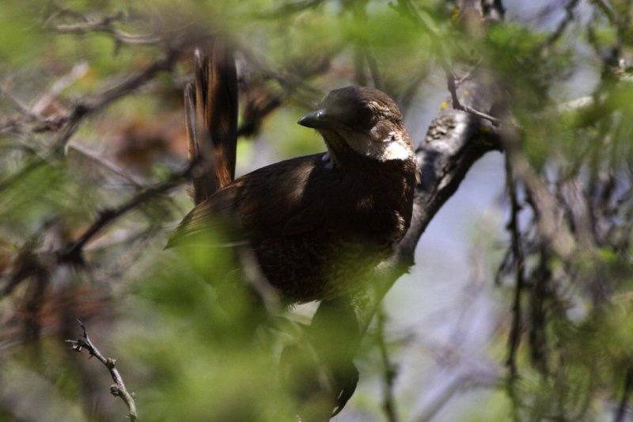
Moustached Turca
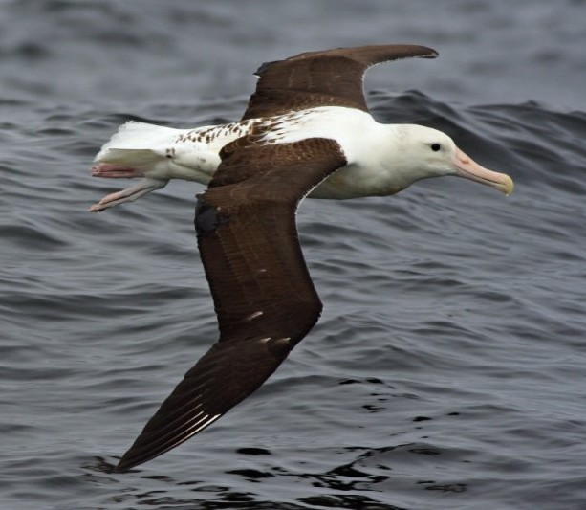
Northern Royal Albatross
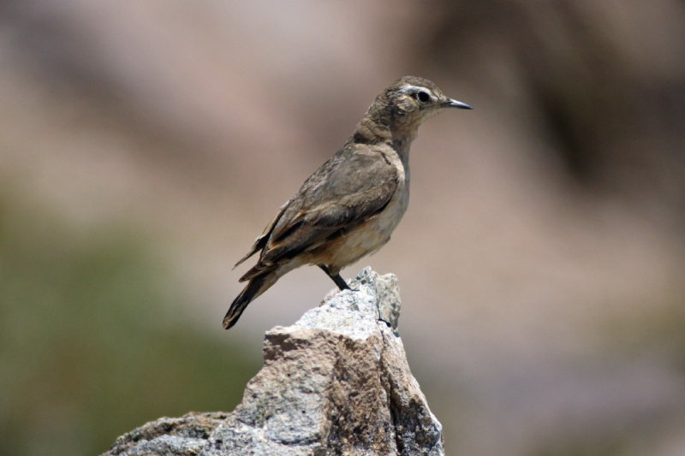
Rufous-banded Miner
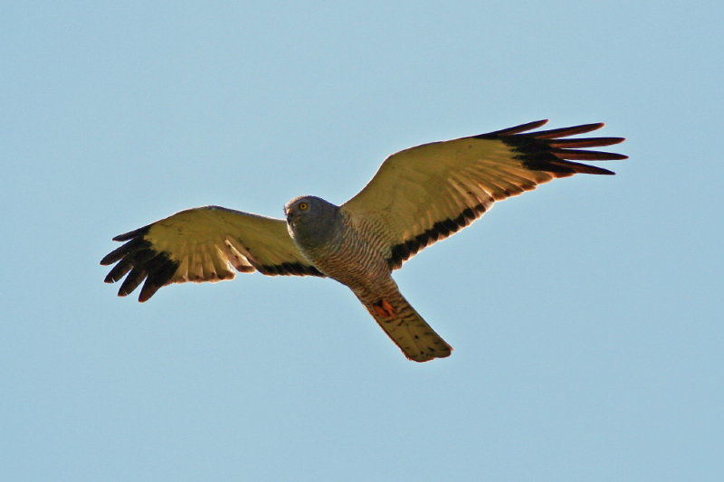
Cinereous Harrier
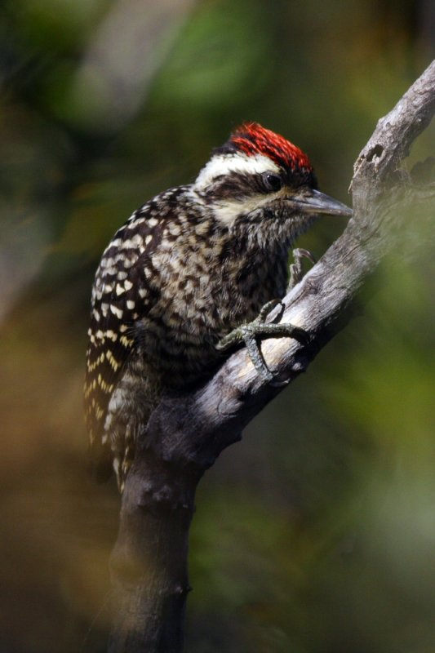
Striped Woodpecker

Bird List

The * indicates a species whose total range is less than 50.000 km²
The species in bold are globally endangered species. The abbreviation in front of the species name indicate the threat level (nt: near-threatened, Vul: Vulnerable, End: Endangered, Crit: Critical)

* Chilean Tinamou - Nothoprocta perdicaria
2 flushed in the Mahuida private reserve.

Puna Tinamou - Tinamotis pentlandii
3 birds seen in Bolivia 1 km before the border, 3 on the way back from the Tatio Geysers.

Vul - Humboldt Penguin - Spheniscus humboldti
1 from the ferry between Chiloé island and the continent. Also seen during the Quintero pelagic.

nt - Magellanic Penguin - Spheniscus magellanicus
30+ from the ferry between Chiloé island and the continent.

Pied-billed Grebe - Podilymbus podiceps
Few birds in the Lampa wetlands.

White-tufted Grebe - Rollandia rolland
1-2 in the Lampa wetlands

Great Grebe - Podiceps major
Few in the Caullin bay on Chiloé island, and several pairs on the lake before the Nahuelbuta NP.

Silvery Grebe - Podiceps occipitalis
The ssp juninensis is common in the altiplano in north Chile, while the birds seen in the Lampa wetlands belong to the ssp occipitalis. These two subspecies are probable forthcoming splits.

End - Northern Royal Albatross - Diomedea sanfordi
4 birds during our Quintero pelagic

Vul - Wandering Albatross – Diomedea exulans
Few birds seen in the Penas Gulf during the Navimag trip

End - Black-browed Albatross - Diomedea melanophris
Few birds including a perfect adult during the Quintero pelagic, 1 during our short pelagic from Juan Fernandez island.

Vul - Salvin's Albatross - Diomedea salvini
The most common albatross during the Quinero pelagic.

Vul - Southern Giant Petrel - Macronectes giganteus
2 from the ferry, between Chiloé island and the continent.

nt - Northern Giant Petrel - Macronectes halli
Few birds during the Quintero pelagic.

Southern Fulmar - Fulmarus glacialoides
Seen during the Quintero pelagic.

Cape Petrel - Daption capense
Seen during the Quintero pelagic.

Kermadec Petrel - Pterodroma neglecta
Every days in the Juan Fernandez islands. They breed on cliffs, and the best views are during the boat trip between the airport and San Juan Bautista.

Vul - Juan Fernandez Petrel - Pterodroma externa
Few birds during a short pelagic trip from Juan Fernandez island.

Vul - White-chinned Petrel - Procellaria aequinoctialis
2 during the Quintero pelagic

Vul - Westland Petrel - Procellaria westlandica
3 in the Corcovado gulf during the Navimag trip

Vul - Pink-footed Shearwater - Puffinus creatopus
More than 500 during the Quintero pelagic, and hundreds around the Juan Fernandez island.

nt - Sooty Shearwater - Puffinus griseus
40+ from the ferry, between Chiloé island and the continent. More than 300 during the Quintero pelagic.

Wilson's Storm-petrel - Oceanites oceanicus
At least 100 during the Quintero pelagic.

White-bellied Storm-petrel - Fregetta grallaria
1 seen during our short pelagic trip from Juan Fernandez island.

End - Peruvian Diving-petrel - Pelecanoides garnotii
Seen during the Quintero pelagic.

Peruvian Pelican - Pelecanus thagus
Common around Arica; few from the ferry between Chiloé island and the continent.
Common in the Quintero harbour.

Peruvian Booby - Sula variegata
Few hundreds around Arica. Also seen during the Quintero pelagic.

Neotropic Cormorant - Phalacrocorax olivaceus
1 bird in the Chungara lake, hundreds in Arica; few around Puerto Montt and on the lake before the Nahuelbuta NP. Also present in the Lampa wetlands.

nt - Guanay Cormorant - Phalacrocorax bougainvillii
A big flock of more than 100 in Arica. Also seen during the Quintero pelagic.

Imperial Shag - Phalacrocorax atriceps
5 from the ferry between Chiloé island and the continent.

nt - Red-legged Cormorant - Phalacrocorax gaimardi
2 near Arica; 2 from the ferry between Chiloé island and the continent, and 10 during the Quintero pelagic.

Cocoï Heron - Ardea cocoï
Around 10 different birds in the Lampa wetlands.

Great White Egret - Egretta alba
1 in the Lluta mouth; 2 around Puerto Montt; fairly common in the Lampa wetlands around Santiago.

Little Blue Heron - Egretta caerulea
1 ad. in the Lluta mouth

Snowy Egret - Egretta thula
10 in the Lluta mouth; fairly common on the shore around Puerto Montt, and in the Lampa wetlands.

Cattle Egret - Bubulcus ibis
Several groups in the agricultural fields, from Chillan to Santiago.

Black-crowned Night-heron - Nycticorax nycticorax
2 birds in Bolivia 1 km before the border, 1 bird building a nest in Arica; 1 in the Alerce Andino NP, and around 10 in the Lampa wetlands.

Black-faced Ibis - Theristicus melanopis
Especially common, and sometimes in large flocks, between Puerto Montt and Victoria.

Puna Ibis - Plegadis ridgwayi
2 on the Chungara lake shore

Chilean Flamingo - Phoenicopterus chilensis
30 birds at the Bolivian border, 10 at the Miscanti lagoon

Black-necked Swan - Cygnus melanocorypha
300+ in the Caullin bay; 300+ on the lake just before the Nahuelbuta NP, and 5 in the Lampa wetlands.

Coscoroba Swan – Coscoroba coscoroba
6 in the Lampa wetlands

Andean Goose - Chloephaga melanoptera
Common in the altiplano in north Chile.

Kelp Goose - Chloephaga hybrida
Few birds seen during the Navimag trip

Flying Steamer-duck - Tachyeres patachonicus
5 in the Caullin bay

Torrent Duck - Merganetta armata
2 birds on the way to El Yeso

Chiloe Wigeon - Anas sibilatrix
Common in the wetlands around Puerto Montt and on the Chiloé island, more than 30 in the Lampa wetlands.

Speckled Teal - Anas flavirostris
Common in the altiplano in north Chile; 2 on the way to the Alerce Andino NP, and 2 in the Lampa wetlands.

Crested Duck - Anas specularioides
Common in the altiplano in north Chile, and 8 in the El Yeso area.

Yellow-billed Pintail - Anas georgica
10 birds in the Chungara lake; common in the wetlands around Puerto Montt and on the Chiloé island. Common in the Lampa wetlands.

White-cheeked Pintail - Anas bahamensis
2 in the Lampa wetlands.

Puna Teal - Anas puna
5 birds in the Chungara lake, 2 in a small lagoon before the Tatio Geysers

Cinnamon Teal - Anas cyanoptera
Common in the Lampa wetlands.

Red Shoveler - Anas platalea
Common in the Lampa wetlands.

Rosy-billed Pochard - Netta peposaca
Present in few number in the Lampa wetlands (including a female with recently born chicks).

Black-headed Duck - Heteronetta atricapilla
The only parasitic duck in the world ! The Lampa wetlands are probably the best place to see this species.

Lake Duck - Oxyura vittata
Common in the Lampa wetlands.

Turkey Vulture - Cathartes aura
Very common in the northern valleys; fairly common between Puerto Montt and Santiago.

Black Vulture - Coragyps atratus
Fairly common between Puerto Montt and Santiago.

nt - Andean Condor - Vultur gryphus
1 imm. over the Zapahuira Polylepis woodland, 5 in the Alerce Andino NP, and few birds around Farellones.

White-tailed Kite - Elanus leucurus
1 before Victoria, and 6 in the Lampa wetlands.

Cinereous Harrier - Circus cinereus
2 in the Lampa wetlands

Harris's Hawk - Parabuteo unicinctus
1 bird seen in the Mahuida private reserve.

Black-chested Buzzard-eagle - Geranoaetus melonoleucus
Few birds seen around Santiago.

White-throated Hawk - Buteo albigula
1 in the Alerce Andino NP, 1 in the Nahuelbuta NP.

Red-backed Hawk - Buteo polyosoma
2 in the Lluta valley; 2 in the Nahuelbuta NP

Juan Fernandez Hawk – Buteo polyosoma exsul
2 birds seen and 1 photographed on the Juan Fernandez island. This (sub)species only breed on Selkirk island, but there are rare sightings from Juan Fernandez island.

Puna Hawk - Buteo poecilochrous
1 bird in Bolivia, between La Paz and Putre.

Mountain Caracara - Phalcoboenus megalopterus
About 10 birds seen at the border between Bolivia and Chile, and 1 near Farellones.

Southern Caracara - Caracara plancus
Excellent views in the Alerce Andino NP, and several sights between Puerto Montt and Victoria.

Chimango Caracara - Milvago chimango
common in central and south Chile.

American Kestrel - Falco sparverius
1 in Bolivia, 3 in the Lluta valley, 1 in the Camarones valley; common in central Chile.
We also saw the fernandensis subspecies on the Juan Fernandez island.

Aplomado Falcon - Falco femoralis
1 near the Miscanti lagoon

California Quail - Callipepla californica
Common around Termas de Chillan, and in the Mahuida private reserve.

Plumbeous Rail - Pardirallus sanguinolentus
1 heard and 1 seen in the Nahuelbuta NP, also in the Lampa wetlands.

Spot-flanked Gallinule - Gallinula melanops
2 adults with chicks in the Lampa wetlands.

White-winged Coot - Fulica leucoptera
Common in the Lampa wetlands.

Andean Coot - Fulica ardesiaca
Common in the altiplano in north Chile.

Red-gartered Coot - Fulica armillata
Common in the Lampa wetlands

Red-fronted Coot - Fulica rufifrons
Common in the Lampa wetlands

Giant Coot - Fulica gigantea
Common in the altiplano in north Chile.

Horned Coot - Fulica cornuta
More than 30 at the Miscanti lagoon

South American Painted-snipe - Nycticryphes semicollaris
4 in the Lampa wetlands.

Magellanic Oystercatcher - Haematopus leucopodus
2 near Maullin.

Blackish Oystercatcher - Haematopus ater
2 on the rocky coast south of Arica; 1 on a rocky shore close to Puerto Montt and 2 seen near Quintero.

American Oystercatcher - Haematopus palliatus
50 in the Lluta mouth; common on the shore around Puerto Montt and on the Chiloé island.

White-backed Stilt - Himantopus (mexicanus) melanurus
5 in the Lampa wetlands.

Andean Avocet - Recurvirostra andina
10 birds in Bolivia, and about 10 more birds in Chile at the border

Peruvian Thick-knee - Burhinus superciliaris
2 in the Azapa valley

Southern Lapwing - Vanellus chilensis
Very common in southern and central Chile.

Andean Lapwing - Vanellus resplendes
1 on the Chungara lake shore

Gray Plover - Pluvialis squatarola
1 in the Lluta mouth

Semipalmated Plover - Charadrius semipalmatus
4 in the Lluta mouth

Killdeer - Charadrius vociferus
1 in the Lluta mouth

Puna Plover - Charadrius alticola
2 ind at the Bolivian border, 6 on a small marsh before the Tatio Geysers

nt - Diademed Plover - Phegornis mitchelli
Excellent view on 4 birds in El Yeso.

South American Snipe - Gallinago paraguaiae
1 scope view close to Termas de Chillan, and 2 at El Yeso.

Hudsonian Godwit - Limosa haemastica
50+ in the Caullin bay.

Hudsonian Whimbrel - Numenius phaeopus hudsonicus
30 in the Lluta mouth; common around Puerto Montt and on the Chiloé island, and 4 near Quintero.

Greater Yellowlegs - Tringa melanoleuca
4 in the Lluta mouth; fairly common around Puerto Montt and on the Chiloé island.

Lesser Yellowlegs - Tringa flavipes
Few in the Lampa wetlands.

Spotted Sandpiper - Actitis macularia
1 on the rocky shore south of Arica

Sanderling - Calidris alba
200+ in the Caullin bay.

Ruddy Turnstone – Arenaria interpres
15+ in the Quintero harbour

Semipalmated Sandpiper - Calidris pusilla
1 in the Lluta mouth

Least Sandpiper - Calidris minutilla
1 in the Lluta mouth

Baird's Sandpiper - Calidris bairdii
10-20 birds at the Bolivian border, 4 on a small marsh before the Tatio Geysers; 50+ in the Caullin bay, and 1 at El Yeso.

Wilson's Phalarope - Phalaropus tricolor
21 birds in a small piece of water in Bolivia, 9 in the Lluta mouth

Red Phalarope – phalaropus fulicarius
50+ during the Quintero pelagic.

Gray-breasted Seedsnipe - Thinocorus orbignyianus
2 seen and more heard on a small marsh before the Tatio geysers, and 2 at the Farellones ski lift.

Chilean Skua - Catharacta chilensis
25 in the Penas gulf and 4 in the Corcavado gulf during the Navimag trip

Pomarine Jaeger – Stercorarius pomarinus
1 during the Quintero pelagic

Belcher's Gull - Larus belcheri
Common around Arica

Gray Gull - Larus modestus
Hundreds around Arica, and 4 during the Quintero pelagic

Kelp Gull - Larus dominicanus
30-50 in the Lluta mouth, common around Puerto Montt and Quintero, and 1 bird in the Juan Fernandez island where the species is a vagrant.

Brown-hooded Gull - Larus maculipennis
Common on the shore around Puerto Montt, at the lake close to the Nahuelbuta NP and around Lampa.

Andean Gull - Larus serranus
Common in the altiplano in north Chile.

Franklin's Gull - Larus pipixcan
1 on the shore close to Puerto Montt, common around Quintero.

Elegant Tern - Sterna elegans
4 in the Lluta mouth

South American Tern - Sterna hirundinacea
2 at Maullin, and 2 during the Quintero pelagic

Common Tern - Sterna hirundo
20 from the ferry, on the way back from Chiloé island to the continent.

Snowy-crowned Tern - Sterna trudeaui
1 on the way to the Alerce Andino NP.

Inca Tern - Larosterna inca
Seen during our pelagic trip from Quintero.

Black Skimmer - Rynchops niger
1 in the Lluta mouth; 100+ in the Caullin bay, and 25 during the Quintero pelagic

Rock Pigeon - Columba livia
Every cities

Spot-winged Pigeon - Columba maculosa
2 in Putre

* Chilean Pigeon - Columba araucana
1 on road to Maullin, a flock on the way to Victoria, and 1 on road to El Yeso.

Eared Dove - Zenaida auriculata
Few number around Arica, 10 in the Camarones valley, common around Santiago.

West Peruvian Dove - Zenaida meloda
Very common around Arica

Picui Dove - Columbina picui
Fairly common around Santiago

Croaking Ground-dove - Columbina cruziana
Common around Arica, heard in the Camarones valley

Bare-faced Ground-dove - Metriopelia ceciliae
Common around Putre

Black-winged Ground-dove - Metriopelia melanoptera
Very common around Putre, common in the highlands around Santiago.

Golden-spotted Ground-dove - Metriopelia aymara
10 birds in Bolivia 1 km before the border

Austral Parakeet - Enicognathus ferrugineus
Especially common in the Nahuelbuta NP and around Termas de Chillan.

* Slender-billed Parakeet - Enicognathus leptorhynchus
A total of 11 birds around Maullin.

Monk Parakeet - Myopsitta monachus
Feral birds in Santiago

Magellanic Horned Owl - Bubo magellanicus
1 flushed in the Camarones valley gave us a wonderful view !
3 (2 adults and 1 immature) at Lampa.

Rufous-legged Owl - Strix rufipes
1 excellent view in the Alerce Andino NP.

Austral Pygmy-owl - Glaucidium nanum
Heard only in the Mahuida private reserve

Burrowing Owl - Athene cunicularia
2 in the Azapa valley, and around the Lampa wetlands

Short-eared Owl - Asio flammeus
1 around Maullin, and 1 on two dates on Juan Fernandez island.

Band-winged Nightjar - Caprimulgus longirostris
1 flushed in the Azapa valley

Andean Swift - Aeronautes andecolus
Around 15 in the Chaca valley

Andean Hillstar - Oreotrochilus estella
Very common around Putre, 2 in the Zapahuira Polylepis woodland

White-sided Hillstar - Oreotrochilus leucopleurus
1 seen around Farellones

Giant Hummingbird - Patagona gigas
1 between Putre and Zapahuira, and few around Santiago.

Green-backed Firecrown - Sephanoides sephaniodes
Very common in the Alerce Andino NP, but also in the Nahuelbuta NP and around Termas de Chillan. Very common in the Juan Fernandez island.

* Crit - Juan Fernandez Firecrown - Sephanoides fernandensis
One of the most beautiful hummingbird in the world !! The sexual dimorphism in this species is incredible !
At least 6 males in the gardens of San Juan Bautista.

Oasis Hummingbird - Rhodopis vesper
Abundant at the "Hummingbird Paradise" owned by the Madrid family in the Azapa valley (with young at nest), 1 in the Chaca valley

Peruvian Sheartail - Thaumastura cora
Very common at the "Hummingbird Paradise" owned by the Madrid family in the Azapa valley

* End - Chilean Woodstar - Eulidia yarrellii
2 males displaying in the Chaca valley

Ringed Kingfisher - Megaceryle torquata
2 in the Alerce Andino NP.

Striped Woodpecker - Picoides lignarius
1 pair in the Mahuida private reserve

Chilean Flicker - Colaptes pitius
1 near Termas de Chillan; 1 good view in the Mahuida private reserve.

Magellanic Woodpecker - Campephilus magellanicus
Heard in the Alerce Andino NP.

Grayish Miner - Geositta maritima
4 seen on the way to the Miscanti lagoon

Puna Miner - Geositta punensis
1 near the Miscanti lagoon

Rufous-banded Miner - Geositta rufipennis
Common in the highland around Santiago.

Creamy-rumped Miner - Geositta isabellina
1 seen near Vallee Nevado

Scale-throated Earthcreeper - Upucerthia dumetaria
1 displaying on the way back from the Tatio geysers, also seen in the mountains around Santiago.

* White-throared Earthcreeper - Upucerthia albigula
1 around Putre

Plain-breasted Earthcreeper - Upucerthia jelskii
2 around Putre (feeding chicks at nest)

Straight-billed Earthcreeper - Upucerthia ruficauda
6 between Zapahuira and the Lluta valley

* Crag Chilia - Chilia melanura
One pair close to Farellones.

Bar-winged Cinclodes - Cinclodes fuscus
1 at the Bolivian border, 1 in Putre, common around Farellones and at El Yeso.

Gray-flanked Cinclodes - Cinclodes oustaleti
Few birds around Farellones.

Dark-bellied Cinclodes - Cinclodes patagonicus
Few birds around Puerto Montt and 2 in the Termas de Chillan.

Seaside Cinclodes - Cinclodes nigrofumosus
2 on the rocky shore south of Arica, 2 seen around Quintero.

Wren-like Rushbird - Phleocryptes melanops
Common in the Lampa wetlands

Thorn-tailed Rayadito - Aphrastura spinicauda
Common in the Alerce Andino NP, Nahuelbuta NP and around Termas de Chillan.

Plain-mantled Tit-spinetail - Leptasthenura aegithaloides
1 of the ssp grisescens in the Camarones valley; the ones we saw in the Mahuida private reserve belong to the nominate aegithaloides subspecies. (forthcoming splits are possible in the Plain-mantled Tit-spinetail complex).

Streaked Tit-spinetail - Leptasthenura striata
Common around Putre and in the Zapahuira Polylepis woodland

Des Murs's Wiretail - Sylviorthrhynchus desmursii
1 good view near Caullin, and few more birds around Termas de Chillan.

* Canyon Canastero - Asthenes pudibunda
1 around Putre and possibly 1 more at the Chapiquiña electric station (not a good view of a canastero with a very rufous tail and wing)

Cordilleran Canastero - Asthenes modesta
2 around Putre and 1 at the Chapiquiña electric station, few around the Tatio geysers and the Miscanti lagoon, 5 around Farellones.

* Dusky-tailed Canastero - Asthenes humicola
Fairly common in the Mahuida private reserve, and 4 near Lampa.

Dark-winged Canastero - Asthenes (dorbignyi) arequipae
Very common around Putre and in the Chapiquiña Polylepis woodland

* Chestnut-throated Huet-huet - Pteroptochos castaneus
2 birds very well seen around the Termas de Chillan.

* Black-throated Huet-huet - Pteroptochos tarnii
Several heard and 1 excellent view in the Alerce Andino NP.

* Moustached Turca - Pteroptochos megapodius
We contacted the species (seen and heard) in the Mahuida private reserve, around Farellones and on the way to El Yeso.

* White-throated Tapaculo - Scelorchilus albicollis
1 in the Mahuida private reserve.

* Chucao Tapaculo - Scelorchilus rubecula
Fairly common in the Alerce Andino NP.

* Ochre-flanked Tapaculo - Eugralla paradoxa
1 excellent view in the Alerce Andino NP.

Magellanic Tapaculo - Scytalopus magellanicus
1 seen in the Alerce Andino NP, heard in the Nahuelbuta NP and around Termas de Chillan.
Also 2 excellent view around Farellones.

Rufous-tailed Plantcutter - Phytotoma rara
1 pair near Maullin, 2 at Mahuida, 1 at Quintero, and 1 near Farellones

White-crested Elaenia - Elaenia albiceps
3 of the ssp modesta or "Peruvian" White-crested Elaenia (that will probably be split from the chilensis sub-species); the ssp chilensis was very common in central Chile

Pied-crested Tit-tyrant - Anairetes reguloides
2 in the Camarones valley

Yellow-billed Tit-tyrant - Anairetes flavirostris
Few around Putre and in the Chapiquiña Polylepis woodland

Tufted Tit-tyrant - Anairetes parulus
2 around Maullin, also seen around Santiago.

* nt - Juan Fernandez Tit-tyrant - Anairetes fernandezianus
Few birds seen in the shrubbery above San Juan Bautista in the Juan Fernandez island.

Warbling Doradito - Pseudocolopteryx flaviventris
1 seen in the Lampa wetlands; the Chilean birds will probably be splitted in the future (the song is very different from the Argentinean birds).

Many-colored Rush-tyrant - Tachuris rubrigastra
Common in the Lampa wetlands

Vermilion Flycatcher - Pyrocephalus rubinus
Few in the Azapa, Lluta and Camarones valleys

Austral Negrito – Lessonia rufa
At least 4 at Lampa

Andean Negrito - Lessonia oreas
2 at the Bolivian border, 2 on a small marsh before the Tatio geysers

Spectacled Tyrant - Hymenops perspicillatus
1 female near Maullin; at least 3 males in the Lampa wetlands.

D'Orbigny's Chat-tyrant - Ochthoeca oenanthoides
2 in the Chapiquiña Polylepis woodland

White-browed Chat-tyrant - Ochthoeca leucophrys
3 around Putre and 2 at the Chapiquiña electric station

Patagonian Tyrant - Colorhamphus parvirostris
1 in the Alerce Andino, and 1 breeding pair in the Nahuelbuta NP.

Rufous-webbed Bush-tyrant - Polioxolmis rufipennis
1 in the Chapiquiña Polylepis woodland

Fire-eyed Diucon - Xolmis pyrope
Fairly common in central Chile.

Black-billed Shrike-tyrant - Agriornis montana
1-2 birds around Farellones

Spot-billed Ground-tyrant - Muscisaxicola maculirostris
4 around Putre

White-fronted Ground-tyrant - Muscisaxicola albifrons
2 below the Tatio geysers

Ochre-naped Ground-tyrant - Muscisaxicola flavinucha
1 at the Miscanti lagoon

White-browed Ground-tyrant - Muscisaxicola albilora
Few birds seen in the highlands around Santiago

Black-fronted Ground Tyrant – Muscisaxicola frontalis
At least 5 at the Farellones ski area

Chilean Swallow - Tachycineta leucopyga
Very common in central Chile.

Blue-and-white Swallow - Notiochelidon cyanoleuca
Few numbers in the Lluta, Azapa and Camarones valley; seen around the Termas de Chillan, and in the Lampa wetlands.

Andean Swallow - Haplochelidon andecola
15 in Bolivia, on the way between La Paz and Putre (more or less one hour driving before the border)

Barn Swallow - Hirundo rustica
1 in the "Pampa de los tamarugales", 1 in Maullin, and 2 in the Lampa wetlands.

Correndera Pipit - Anthus correndera
In the Lampa wetlands

Grass Wren - Cistothorus platensis
1 around Maullin, and at least 1 seen and 1 heard in the Lampa wetlands

Southern House Wren - Troglodytes aedon
Few number of the ssp tecellatus in the Azapa and Camarones valley; very common in central Chile.

* Chilean Mockingbird - Mimus thenca
Only 1 in the Lampa wetlands !! but lot's of them around Santiago, especially in the Mahuida park, or the Maipu canyon.

Chiguanco Thrush - Turdus chiguanco
5 of the chiguanco ssp in Putre and 2 in the Chapiquiña Polylepis woodland, 2 of the anthracinus ssp in San Pedro de Atacama.

Austral Thrush - Turdus falcklandii
Very common in central Chile and on the Juan Fernandez island.

Rufous-collared Sparrow - Zonotrichia capensis
Almost everywhere.

Black-hooded Sierra-finch - Phrygilus atriceps
1 at the Bolivian border, few numbers in Putre and in the Chapiquiña Polylepis woodland, 1 at the Tatio geysers

Gray-hooded Sierra-finch - Phrygilus gayi
Common in the mountains around Santiago.

Patagonian Sierra-finch - Phrygilus patagonicus
Very common around Puerto Montt, in the Alerce Andino NP, and around Termas de Chillan.

Mourning Sierra-finch - Phrygilus fructiceti
Abundant around Putre and in the Chapiquiña Polylepis woodland, at least 10 around Farellones.

Plumbeous Sierra-finch - Phrygilus unicolor
1 at the Tatio geysers, 5 at El Yeso

Red-backed Sierra-finch - Phrygilus dorsalis
2 at the Tatio Geysers

Ash-breasted Sierra-finch - Phrygilus plebejus
Common around Putre and in the Zapahuira Polylepis woodland, common below the Tatio geysers.

Band-tailed Sierra Finch – Phrygilus alaudinus
Common at Farellones

Common Diuca-finch - Diuca diuca
2 in the Lampa wetlands.

* nt - Slender-billed Finch - Xenospingus concolor
Fairly common in the Azapa, Chaca and Camarones valley, and in the Lluta mouth

Bright-rumped Yellow-finch - Sicalis uropygialis
1 male in full breeding plumage is singing at the Miscanti lagoon

Greater Yellow-finch - Sicalis auriventris
A flock of about 15 birds at the Miscanti lagoon, common around Farellones.

Greenish Yellow-finch - Sicalis olivascens
Common around Putre and Zapahuira, common below the Tatio geysers.

Saffron Finch - Sicalis flaveola
A pair in the Maullin village. A big range extension !!! (the closest known population in Chile occurs near Villarica, around 200 km farther north).

Grassland Yellow-finch - Sicalis luteola
Common around Maullin, and in the Lampa wetlands.

Chestnut-throated Seedeater - Sporophila telasco
3 in the Azapa valley

Band-tailed Seedeater - Catamenia analis
In Putre and in the Chapiquiña Polylepis woodland

Blue-and-yellow Tanager - Thraupis bonariensis
1 in Putre

nt - Giant Conebill - Oreomanes fraseri
1 in the Chapiquiña Polylepis woodland

Black-throated Flowerpiercer - Diglossa brunneiventris
1 in Putre

American Redstart - Setophaga ruticilla
Skip found a first year male in the Eucalyptus patch in Putre... a vagrant (fourth record and first confirmed with pictures) in the first 24 hours in Chile, well done Skip !!!

* Vul - Tamarugo Conebill - Conirostrum tamarugense
1 bird singing and then carrying food in the "Pampas de los Tamarugales"

Cinereous Conebill - Conirostrum cinereum
Common in Putre, and in the Azapa, Lluta and Camarones valleys

Yellow-winged Blackbird - Agelaius thilius
Common in the Lampa wetlands

Peruvian Meadowlark - Sturnella bellicosa
Common in the Lluta mouth and Lluta valley.

Long-tailed Meadowlark - Sturnella loyca
Very common in central Chile.

Austral Blackbird - Curaeus curaeus
1 in the Alerce Andino NP, and several near Termas de Chillan. Also found around Santiago.

Shiny Cowbird - Molothrus bonariensis
1 in the Lampa wetlands

Thick-billed Siskin - Carduelis crassirostris
2 in the Chapiquiña Polylepis woodland

Hooded Siskin - Carduelis magellanica
Common around Putre and in the Azapa valley

Black Siskin - Carduelis atrata
3 birds singing below the Tatio geysers

Yellow-rumped Siskin - Carduelis uropygialis
Few groups around El Yeso.

Black-chinned Siskin - Carduelis barbata
Common around Puerto Montt, in the Alerce Andino NP, Nahuelbuta NP, and around Termas de Chillan.

House Sparrow - Passer domesticus
Almost every towns and cities.

Mammal List

Juan Fernandez Fur Seal – Arctocephalus philippii
50-100 at sea close to the airport, and close view on a small group during the boat trip between the airport and San Juan Bautista

South American Sea Lion – Otaria byronia
Common on the coast. Several colonies seen during the Navimag trip, around Puerto Montt and in the Quintero harbour.

Guanaco – Lama guanicoe
Few seen above Putre

Vicugna – Vicugna vicugna
Common in highlands in the north of Chile

Austral Viscacha – Lagidium viscacia
Few above Putre and near the Miscanti lagoon

Coypu – Myocastor coypus
Common in the Lampa wetlands

