Birding Trip

in Peru

SOUTHERN CIRCUIT

November 27 to December 12, 2005

by Fabrice SCHMITT
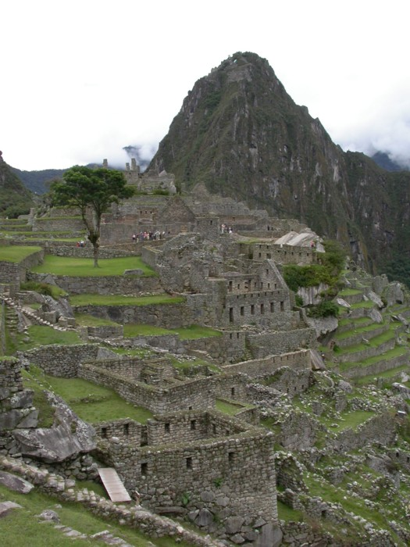

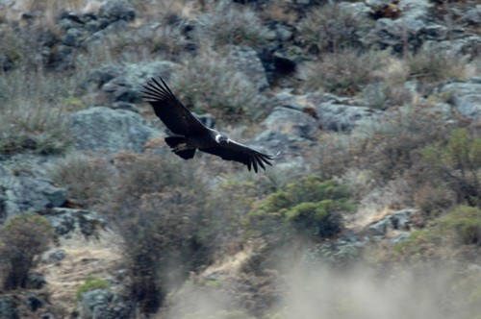



Impassioned by ornithology for more than 20 years, I fell in love with the birds from South America at the time of my first trip to Peru in 1995.

Digiscoping in Amazonia.
Since this trip, I explored the continent by visiting almost all the countries, with the aim to discover its fauna, its flora, its people...
But Andean countries, and particularly Peru, kept my predilection. I already spent more than one year in Peru, if I add up all the trips I carried out in this country. Nevertheless, lots remain to be discovered!

Since July 2005 I live in Santiago of Chile, where I carry out many activities with the association of study and protection of birds UNORCH (Union de los ORnitologos CHilenos). Professionally, I work like nature guide for Kolibri Expeditions, a travel agency specialized in birding trip in Peru and all the neighbouring countries. Gunnar Engblom, the owner of this agency, is one of the best birders of Peru. With Kolibri Expeditions, you can carry out the trip of your dreams, in Amazonia or high mountain (or both...), for long or short duration, if you are a hard core ticker or a slowpace birder !
For more information, consult http://www.kolibriexpeditions.com or kolibriexp@gmail.com

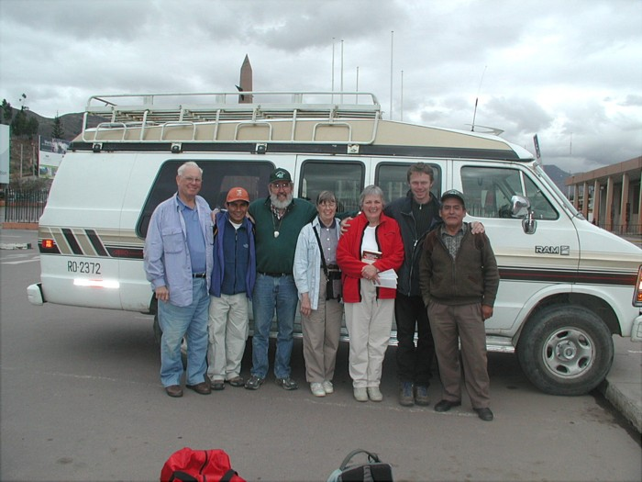
All the team, from left to right : Frederick, Enrique, Stanley, Sue, Jean, Fabrice and our wonderful driver Adriano.
In December 2005, I had the pleasure to guide Sue and Stanley KAUFMAN as well as Jean and Frederick DIVELY throughout the "Southern Circuit", a new trip to the program of Kolibri Expeditions. This circuit is perfect for those who want to discover Peruvian fauna, without missing the cultural aspect of this marvellous country. For that, two guides accompanied the group throughout the trip, one for the culture part (Enrique Loayza) and the other for the nature part (my self !). This report summarizes what we visited and observed at the time of this circuit. The first two days presented in this report (pelagic and visit of the "Lomas de Lachay") do not form part of Southern Circuit. They are optional days which one can make from Lima.

For more information regarding this trip or Peru in general, do not hesitate to contact me: fabrschmitt@yahoo.com.ar

November 27, pelagic day from Lima

Kolibri Expeditions is the only agency that organizes pelagic trips from Lima. The principal goal of these is to observe seabirds (albatross, petrels, strom-petrels, gulls, etc...), but many marine mammals are often also observed (whales, dolphins and sea lions). When the boat is about 40 miles off the coast, the distance necessary to arrive to the Humboldt current (upwelling of cold, and plancton and fish rich waters, and thus rich in birds...), fish remainders are thrown at sea to attract petrels and albatrosses. Those are generally seen very close to the boat which makes it possible to take superb pictures. The boat passes close to some islands, where two small colonies of Humboldt Penguin as well as an enormous colony of sea lions (more than 3000 individuals) can be seen.

At the time of our visit, we could approach some large fishing vessels, where the quantity of birds were unimaginable!! In November, the Franklin gulls are wintering along the Peruvian coast, and we observed several tens of thousands of this species !
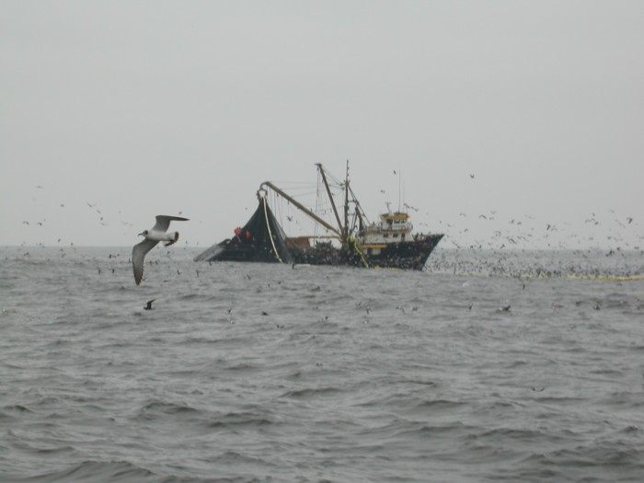

A few thousands of Franklin gulls around a fishing vessel

The most remarkable species observed during this pelagic, were: Humbolt Penguin (more than 50 ind.), Waved Albatross (superb observations of 3 ind.), White-chinned Petrel (10 ind. of which some posed with a few meters of the boat), Pink-footed Shearwater (10 ind. among hundreds of Sooty Shearwater), Wilson's, White-vented, Wedge-rumped and Black Storm-petrel, Peruvian Diving-petrel (1 only ind. of this rare and threatened species), Red-legged Cormorant, Swallow-tailed Gull (1 ind. which was unfortunately not observed by the whole group...), Inca Tern (100s of birds come to feed with a few meters of the boat !!), etc...

The complete list of the birds observed during this day is given to the end of the trip report.
November 28, Lomas de Lachay and Ventanilla.

Located at a hundred kilometer to the north of Lima, Lomas de Lachay is an oasis in the middle of the coastal desert. Indeed, because of a particular topography, it is sometimes possible that the coastal fog (omnipresent from May to September) condenses and humidifies the ground, thus allowing the development of the vegetation.
These islands of greenery are called lomas. Unfortunately, because of a strong human pressure, the majority of these lomas were deforested and their regeneration is extremely slow. It was also the case for the lomas of
Lachay, but as a national reserve the area preserves this splendid place henceforth.

We observed some of the specialities of this reserve, such as Thick-billed Miner (endemic species of Peru), Raimondi's Yellow-finch (species generally difficult to find, but large groups are always present in this reserve during the southern summer), the Short-tailed Field-tyrant (a flycatcher with very large legs and short tail, which seeks its food while running on the ground) and Least Seedsnipe (a very particular shorebird resembling a sandgrouse). The bushes of the Nicotiana genus being in flower, tens of hummingbirds (Oasis Hummingbird, Purple-collared Woodstar, Sparckling Violet-ear) were flying everywhere.
We unfortunately did not observe the very rare and discrete Huemul, a reintroduced deer in this reserve and which reproduced there recently.

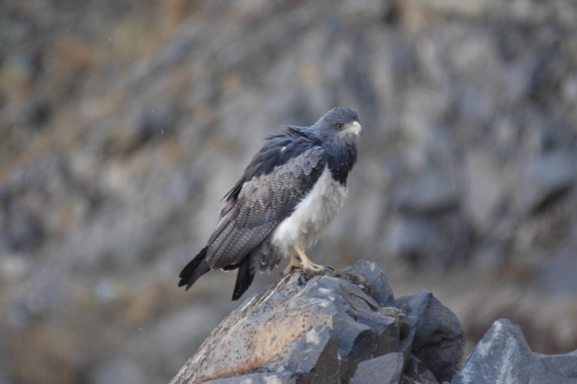

An adult of Black-chested Buzzard-eagle, very common raptor in the
reserve of Lomas de Lachay (photo Eric Didner)

At the time of the return way, we also stopped at the reserve of Ventanilla. It is a vast wetland, strongly threatened by the urbanization of Lima, where it is possible to easily observe many species of marshland: grebes, herons and egrets, shorebirds, etc...
A group of 9 Peruvian Thick-knee (the only species of Thick-knee in Peru) was present at the edge of the principal lagoon in company with Peruvian Meadowlark and some Groove-billed Anis. And in the reedbed, we had the pleasure to spot the beautiful Many-colored Rush-tyrant, Wren-like Rushbird, and even the very secretive Least Bittern.
November 29, Lima – Pisco

First true day of the "Southern circuit". One begins our day by the visit of the Olivar park located at San Isidro ("district" of Lima). The centenary olive-trees attract many birds in the heart of the city. We observed in particular many Vermilion Flycatcher, the omnipresent Rufous-collared Sparrow which we will observe every day during our tour, some Tumbes Beardless-Tyrannulet (a subspecies of Southern BT considered by some as a candidate for species status) and Chimney Swift (nesting in North America but which comes to winter by here).

The greatest surprise of this morning, was the discovery of two adults of Slender-billed Finch, a very localised and threatened species. Bound to the vegetation of the edges of river and to certain cultures (whose plantations of olive-trees...), this species was not observed any more in the surroundings of Lima since more than one century!! The origin of these birds remains a enigma, but it is not impossible that they are escaped birds, because this species is sometimes found on certain bird markets...

The National Museum (Museo de la Nacion) and the Gold Museum then revealed their secrects to us. Before discovering the treasures of Peruvian archaeology in situ, it is essential to be familiarized with the various cultures which followed one another in this country. The Inca culture is only the tip of the iceberg.

During the afternoon, we mainly drove to Pisco (about 4 hours of way). We stopped in Puerto Viejo, superb beach where we observed an endemic bird of the Peruvian coast: Peruvian Seaside Cinclodes. Close to this beach, we also discovered a family of Great Grebe, a giant grebe whose cry reminds us of the song of the divers of the northern hemisphere.

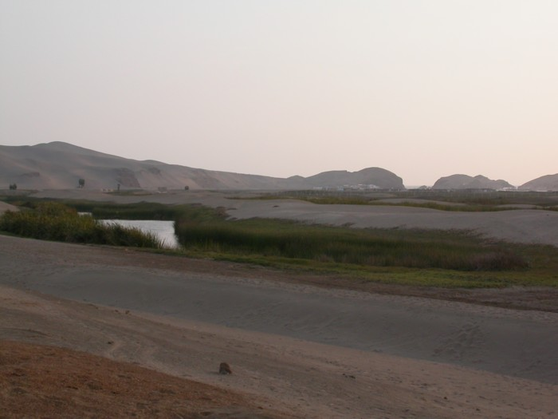
Marsh of Puerto Viejo

November 30, Pisco – Peninsula of Paracas – Ocucaje
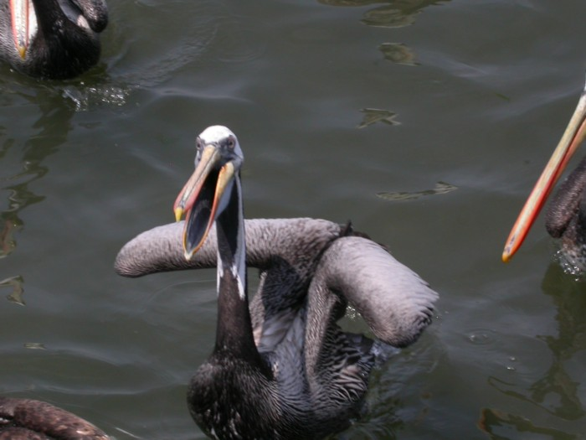
As we already did a pelagic a few days ago, we did not visit the islands of Ballestas. We thus passed the essence of our morning on the peninsula of Paracas, in the search of birds and marine mammals.

Close to the village of Lagunillas, we observed a colony of Southern
Fur Seal, another species of sea lion that the one observed during the pelagic trip from Lima. On the cliff surrounding this colony, many seabirds were nesting, as Inca Terns or Peruvian Boobies.

At the time of our stops to research shorebirds, we observed Blackish and American Oystercatcher, and many species of north-american species wintering in the southern hemisphere: Least and Semipalmated Sandpiper, Semipalmated Plover, Hudsonian Whimbrel, Spotted Sandpiper...

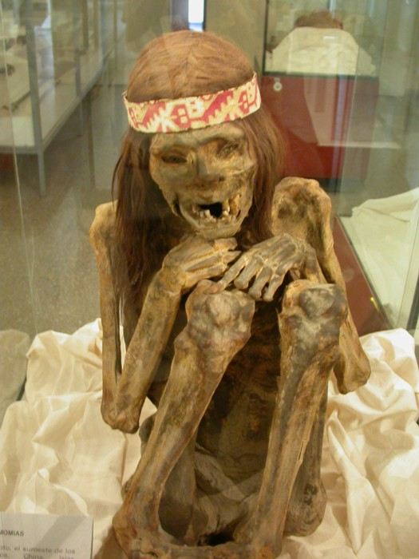

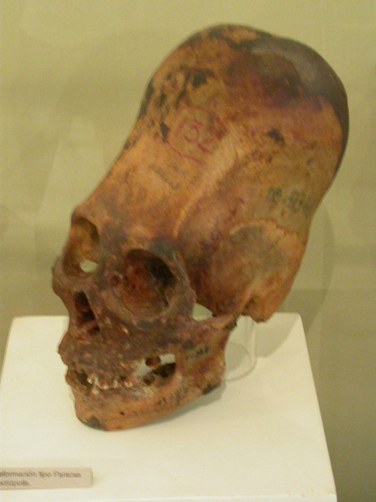

On the way for Ocucaje, we stopped in Ica, to taste some fish specialities as much as paying a visit to visit the museum of the city. Rich with many ceramics from the Nazca and Paracas culture, this museum also has some mummies and deformed craniums. Unfortunately, the most beautiful Paracas fabrics were recently stolen!

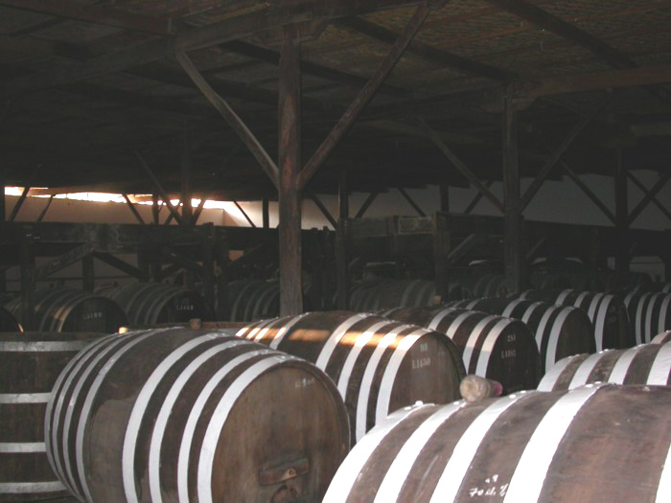
In Ocucaje, we were be lodged on the grounds of the most prestigious distillary of pisco. We benefitted from this obviously visiting the installations to discover all the trade secrets of this drink. But the Ocucaje Winery also produces several excellent wine, and the visit ends of course in the tasting of several of them.
It could not prevent us from trotting on the arable lands nearby, where we made superb observations of several families of Burrowing Owl. Other interesting species in Ocucaje: Amazilia Hummingbird, Coastal Miner, White-crested Elaenia, Long-tailed Mockingbird, Streaked Saltator.
Decembre 1st, Ocucaje – Nasca
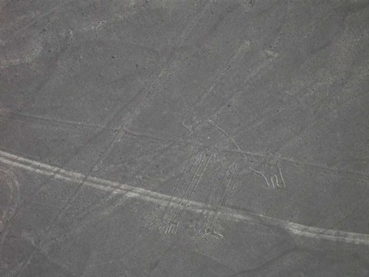
The dog, one of the many lines of Nazca observed during the turn in the plane.
After a breakfast and a birding morning around Ocucaje, we drove to Nazca to fly over the famous lines. It is indeed advisable to take the plane rather early, to fly over the drawings whose significance remains a mystery. The flight takes approximately 30 minutes, and it is essential to take the plane to appreciate the cosmonaut, the hummingbird, the condor, the dog or the lizard. The sight on these drawings is one strong moment of the trip, the more so as the same authors of these drawings never could see their work... some remain convinced they have to be the work of extraterrestrials !

We passed the remainder of the day in Nazca. In the end of the afternoon, we visited the aqueduct of Cantallo. Well before Incas, the inhabitants of the area knew to direct water by building an aqueduct.... underground!! A true wonder of ingeniousness. And the arable lands near the aqueduct, allowed the observations of many birds, one being the rare Slender-billed Finch!! This time, no doubt about the origin of the birds observed!
Many granivores were also present, of which many were Chestnut-throated Seedeaters and a male of Parrot-billed Seedeater.

December 2, Nasca – Punta San Juan – Lomas de Atequipa – Puerto Inca
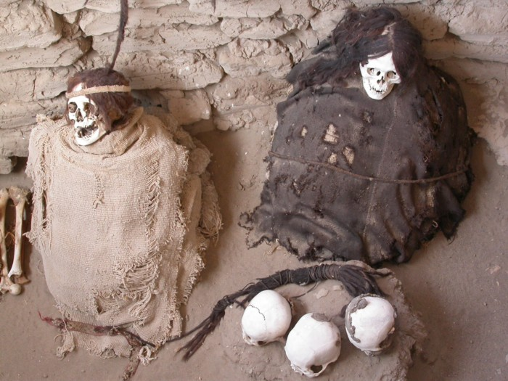
Mummies in the cemetery of Chauchilla
In the Peruvian coastal desert, it rains only one millimetre per
year, on average... Thus, many vestiges of last civilizations were preserved until our days. This is in particular the case of the mummies and bones which one finds in the cemetery of Chauchilla in the surroundings of Nazca. Even if unfortunately the most beautiful tombs were plundered, it is always possible to discover on the site, many mummies and the utensils with which they were buried.

After the visit of this cemetery, we went to the reserve of Punta San Juan. This reserve is managed by ProAbono, a state-owned company which exploit the guano deposited by the thousands of cormorants (in great majority Guanay Cormorant, but also some Red-legged Cormorant) that nest there.
One of the major interest of the reserve is a breeding colony of several thousands of Southern Sea Lion and Southern Fur Seal (the period of breeding is shifted, which makes it possible to limit the competition between these two species for the search for a place of reproduction). We also observed several Humbolt Penguin there, an Osprey, and many Turkey Vulture in the search of chicks or carcasses of marine mammal.

Punta San Juan
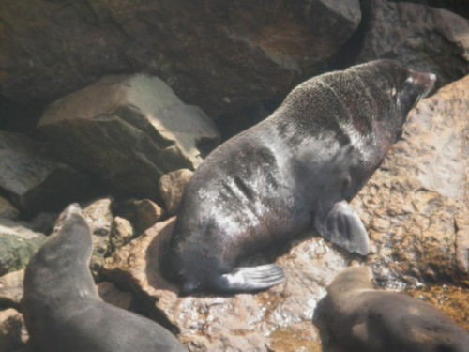
Southern Fur Seal

Following our road towards the south, we made some stops, to admire the perfectly preserved fossil of a whale, or to taste olives produced on the Peruvian coast. The last of these stops enabled us to prospect Loma de Atequipa, where we unfortunately did not discover the subspecies of Common Miner (a good candidate for a new split...). But we observed some Croaking and Black-winged Ground-dove, a male of Band-tailed Sierra-finch, and 5 Collared Warbling-finch.

We spent the night to Puerto Inca, small paradisiac place, with sunset on the Pacific, and desert in the back.... the rumour says that the Inca in person came to bathe here!

December 3, Puerto Inca – Arequipa

A long road still separated us from Arequipa, and, after a copious breakfast at the seaside, we passed the essence of the day to drive towards the white city. Of course we stopped from time to time, to observe a pair of Aplomado Falcon or to try the crayfish (from the river) in a restaurant near Camana.

We unfortunately arrived 30 minutes too late to visit in the course of the day the monastery Santa Catalina, but the city offers other treasures well to be contemplated, to start with its superb central place where it is pleasant to wait the night.
December 4, Lagunas Salinas
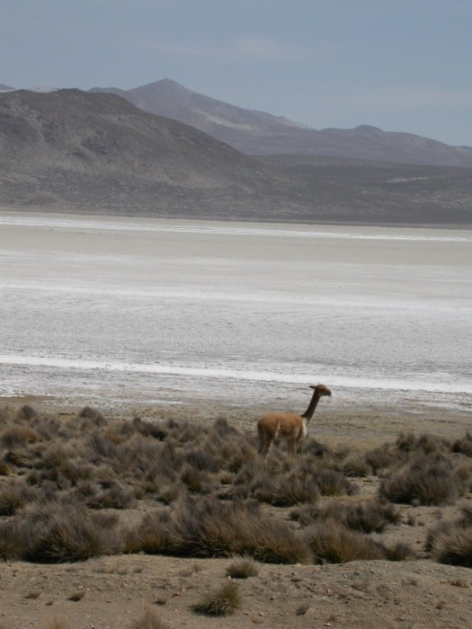
Vicuna in front of the dry Salinas lagoon
Sue and Jean decided to remain in Arequipa and in company of Enrique, they would visit the monastery Santa Catalina as well as a part of the old colonial city. Stan, Fred and I, left early in direction of the Salinas lagoon. The first stop is done in the neighbourhoods of Chiguata, where we seeked the birds related to the semi-arid vegetation.
We found a White-throated Earthcreeper rather quickly, species whose distribution is very limited! We also observed some species of Sierra-finch (Peruvian, Mourning and Band-tailed), a large troop of Greenish Yellow-finch, 5 Blue-and-yellow Tanager and of Dark-winged Canastero. While continuing our accent, we crossed a woodland of Polylepis where we discovered many news species: 1 male of Andean Hillstar, many Black Metaltail, 3 Streaked Tit spinetail, our first Cordilleran Canastero, 2 Black-billed Shrike-tyrant and several Brown-backed Chat-tyrant.

At 4200 m. of altitude, we arrived at the lagoon after 3 hours spent on a track in bad condition.... and unfortunately it is completely dry !!

It should be said that in Peru, the summer 2005 was the driest since about fifteen year, and many wetlands of mountains were drained. Only one tiny pool remained where some water birds concentrate: 4 Andean Goose, 6 Speckled Teal, 2 Crested Duck, 2 Puna Plover, 3 Grey-breasted Seedsnipe and some Andean Negrito. Some passerines of high mountain are also found: Common Miner, Plain-breasted Earthcreeper, Bar-winged Cinclodes and 2 Puna Yellow-finch. We also observed our first Vicunas which do not seem to suffer from the lack of water…
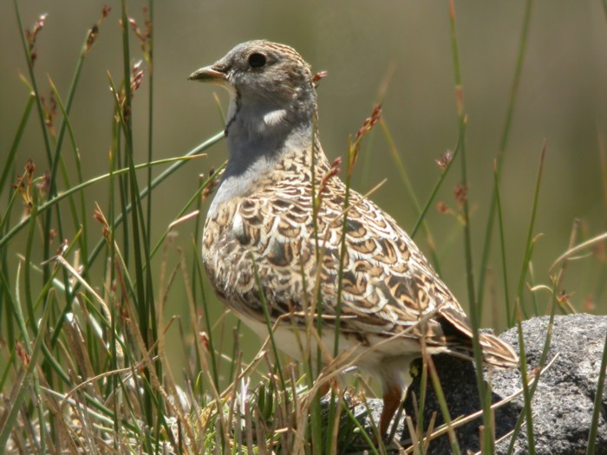
A male Grey-breasted Seedsnipe
December 5, Arequipa – Chivay
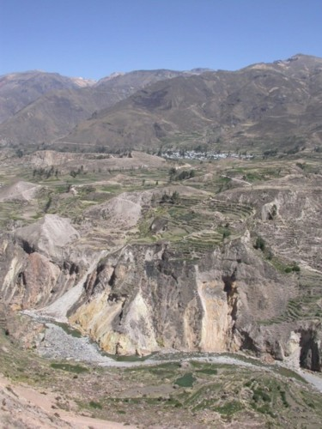
Terraces of the Colca canyon
We left Arequipa at 6h30 a.m. because a long road awaits us to reach Chivay, small village located at the entry of the Colca canyon. On the way, we stopped at the edges of some lagoons where there is still a little water... We discover there 2 Chilean Flamingo and many Puna Ibis. Among the water birds present, we find some individuals of Giant Coot, a species which one finds only at very high altitude. The high Andes are also inhabited by a family of very particular flycatcher, the Ground-tyrants. They live primarily on the ground, and for this reason they have very large legs which makes it possible to run and to catch insects. We observe three species today: Chestnut-naped, Puna and White-fronted Ground-tyrant.

We arrived at the village of Chivay at around 3 p.m., and after a small pause during which we tasted our first coca tea, we would stroll around the village, discovering birds and inhabitants. We observed Giant Hummingbird thus (the largest hummingbird of the world) nourishing nectar of the flowers of cacti, some Chiguanco Thrush which seeked worms in a recently plowed field, and a troop of Andean Swift flied over the village in the late evening.
Un condor adulte (Photo. Eric Didner)

December 6, Chivay – Colca canyon – Puno – Chuquito

Can one imagine to go to Peru without hoping to see a Condor?...
Unfortunately this species is not so easy to observe in Peru, and the world population of this bird is declining. The use of poison to kill pumas and the direct destruction (the condors can kill at times young livestock), are the principal reasons. The Colca canyon is known to be the best place to observe condors at close range (in 2005, nearly 80.000 people came to the canyon from Colca to hope to see some of them). But at the time of our visit, we learnt that it is very difficult to observe condors in December, the bulk of the population being on the Peruvian coast in the search of placenta of sea lions (the reproduction season of the two species present at Peru is spread out through November to February). A local guide even announces to us to have seen them only once during his last five visits... But after one hour of waiting at the famous "t Cross of the condors", we discover our first condor, an adult, which briefly flies over the canyon. We observed in all 5 adults and 2 immatures, the latter admired at less than 100 meters of distance!

After these observations of the "bird of the trip!", we are had to leave the place. Indeed, we needed nine hours to reach Puno, on the edge of the lake Titicaca.

We hardly had time to stop to observe birds, but nevertheless we discovered some Golden-spotted Ground-doves, 2 White-throated Diuca-finches and 1 Puna Hawk.

We spent the night in Chuquito, a few kilometres from Puno.

December 7, Titicaca lake – Sillustani

In order to rest from the previous very long day, the whole of the group decide to make an easy day by the lake and visit the pre-inca ruins of Sillustani. The other possibility for the day, was to look for Puna Rhea, a species on the verge of extinction in Peru (a captive breeding program and project of reintroduction has begun), but the sector where this species occurs is more than 3 hours of dirt road from Chuquito. Enough of dirt roads !
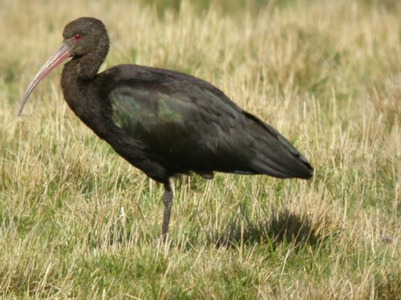
Puna Ibis
The star of the Titicaca lake, for the birders, is without any doubt the Titicaca Flightless Grebe. This apterous species of grebe is endemic to the Titicaca lake ! We spot some of them (3 isolated adults, 1 immature, 1 adult with 2 chicks) not far from Chuquito.

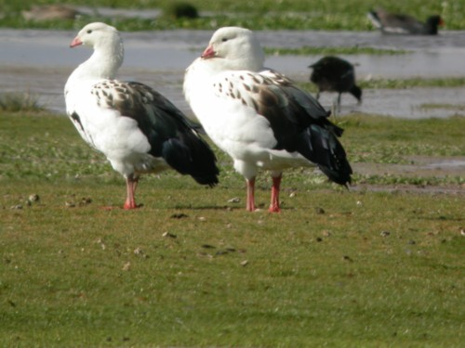
A pair of Andean Goose
But there are also many other species of water birds on the lake, and we observe, many Black-crowned Night-heron (the same species as in the northern hemisphere), more than 100 Puna Ibis, Andean Goose, Crested Duck, Specled Teal, Yellow-billed Pintail, Puna Teal, Cinnamon Teal, Andean Duck, two species of stilts (Black-necked and White-backed Stilt), Greater and Lesser Yellow-legs, Andean Gull and many Mountain Caracara.

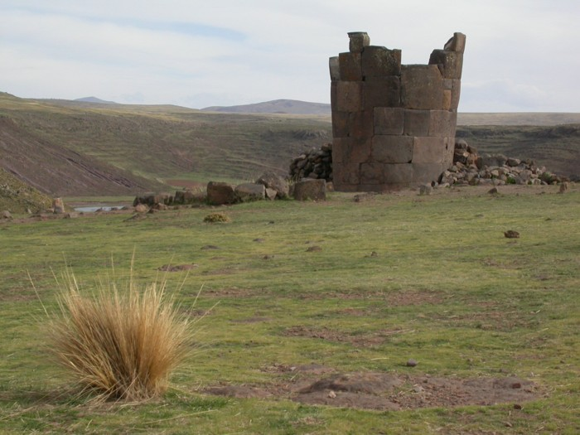
One of the destroyed towers of Sillustani
After a rapid visit in the Uros islands, which is becoming a awful tourist trap and absolutely deprived of charm and of authenticity..., we went to the impressive towers of Sillustani. Although these colossal burial towers (mummies were found inside) were partially destroyed by the incas, one should not miss a visit by these ruins! The landscapes neighbouring is spectacular and some birds are also present (Puna Hawk, Andean Swallow and Black Siskin).

December 8, Chuquito – Cusco

After a copious breakfast and some stops at the edge of the lake to search for Plumbeous Rail (we observed 1 immature close to Puno), we took the road to Cusco. The road is long, but we cross fantastic landscapes and as the road is completely tarred, the drive is rather pleasant.
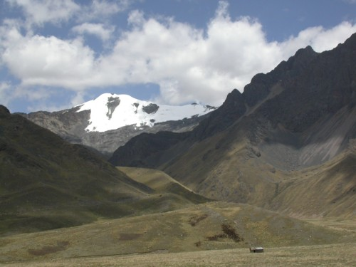
Vilcanota cordillera, at the time of the passage of the pass between Puno and Cusco.

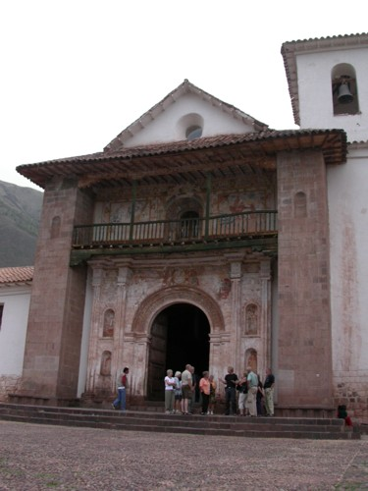
Andahuaylillas church

We took our lunch close to the ruins of the Raqchi Inca temple, dedicated to the creative god Viracocha. And a little before arriving at Cusco, we visited the Jesuit church of Andahuaylillas.
The rich paintings that decorate it has made it been called the nickname of "Sistine Chapel" of South America.

We arrived around 4 p.m. at Cusco, and the end of the afternoon is passed to visit the most beautiful Peruvian city (personal opinion...) and to make some Christmas purchases.

December 9, Cusco – Huacarpay lagoon – Ollantaytambo – Aguas Calientes

Like the whole of the group visited Cusco three weeks ago at the time of another organized circuit, we decided to spend the morning at the Huacarpay lake. We seeked in vain for the endemic hummingbird, the Bearded Mountaineer. On the other hand we observed other species of the family like Sparkling Violet-ear and a male of Green-tailed Trainbearer. In the undergrowth where we seeked for the hummingbirds, we found some Rusty-fronted Canastero (another endemic species) and 2 White-browed Chat-tyrant. On the lagoon, an Osprey in migration came to catch a fish, and on the bank we observe an adult and an immature of Plumbeous Rail.

We then drove along the Urubamba river, which cuts between the Vilcanota and Vilcabamba cordilleras, to the village of Ollantaytambo.
On the way, we observed an adult Condor a very rare species in the Vilcanota cordillera!!

From Ollantaytambo, we traveled by train to reach the Aguas Calientes, where we spent the night. During the way, we observed 12 Torrent Duck (isolated individuals or groups of 2-3 birds), and Stan even managed to find 2 White-capped Dippers.

The change of habitat in only two hours along the railroad is phenomenal, because it is now tropical forest which surrounds us. As we arrived at the luxurious Pueblo Hotel of Aguas Calientes, we observed a large group of tanagers (Blue-grey, Blue-and-yellow, Fawn-breasted, Saffron-crowned, Blue-necked, Silver-backed and Palm Tanager!). We passed the remainder of the day on the grounds of the hotel, scanning the hummingbird feeders where one species of Hummingbirds follows another: Sparckling Violet-ear, Green-and-white Hummingbird (endemic species), Speckled Hummingbird, Chesnut-breasted Coronet, Booted Racket-tail and Long-tailed Sylph.
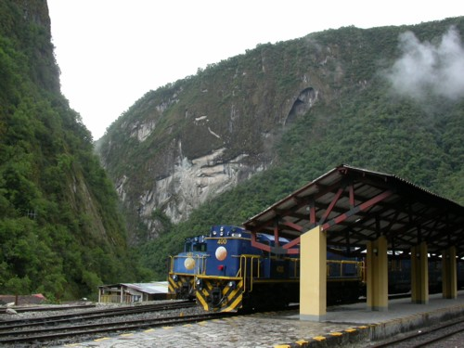
The station of Aguas Calientes!

December 10, Aguas calientes – Machu Picchu – Ollantaytambo

We began our day by checking the surroundings of the Pueblo Hotel.
It should be said that this hotel is in the heart of the mountain forest, and we don't have to walk a lot to see a large amount of species of birds and orchids...

Apart from many of the tanagers and hummingbirds of the day before, we also observed a group of about fifteen Mitred Conure, a splendid Highland Motmot which pearched for 10 minutes only a few meters of our way, 2 White-capped Dippers on the river right in front of the hotel, 1 Swainson Thrush, 2 singing Red-eyed Vireos, many Slate-throated Whitestart, 2 Sclater's Tyrannulet and many others...

After this morning’s introduction to birding in tropical forest, and an incredible breakfast with view on Rio Urubamba, we travelled by bus to the famous ruins of Machu Picchu. Discovered less than one century ago, these inca ruins are the most spectacular of all the South American continent. Located in the middle of a preserved mountain forest, the landscape around these ruins is not less imposing! The visit to Machu Picchu captures the spirit of this southern circuit - "Nature and Culture" - as well as the embarrassment of the a naturalist when visiting Peru for the first time: When visiting the ruins the naturalist keeps an eye in the lookout for a tanager flock in a fruiting tree. He discovers the culture of these lost civilizations while a hummingbird comes to feed in a flower a few meters away..... he does not know where to look!
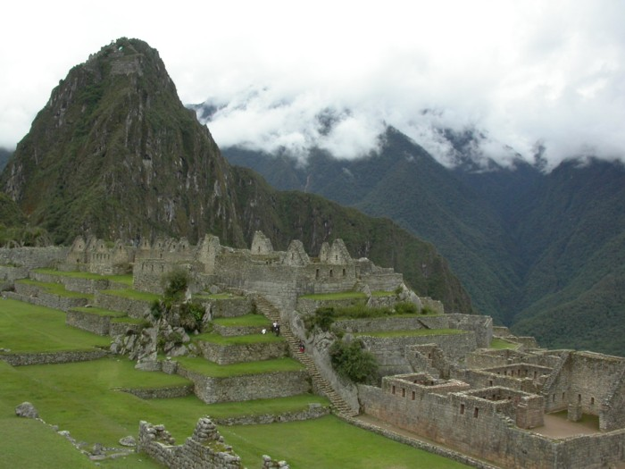
The Machu Picchu
In the afternoon we take the train to Ollantaytambo where we spent the night. On the way back we saw even more Torrent Ducks than on the train ride coming to Aguas Calientes. I spotted a male of Andean Cock-of-the-rock. I am greatful that the rest of the group who did not see this splendid bird did not decide to throw me out of the window of the train...

December 11, Ollantaytambo – Abra Malaga – Canchayoc – Cusco

The road from Ollantaytambo to Canchayoc (and which continues until Quillabamba), while passing by Abra Malaga with more than 4200 meters (Abra = pass in Spanish), starts in the brushy and semy-arid vegetation, crosses the highland puna while passing close to some relict woods of Polylepis, and finishes in the wet mountain forest. This diversity of habitat makes it possible to find an extraordinary number of birds species, and a day is very insufficient to correctly prospect this road. As we just have spent one week in the Andes, we decided to go directly to the mountain forest, in order to look for new species. We are not disappointed since at first stop, we observed 1 Puna Thistletail, 1 Red-crested Cotinga, 2 Rufous-breasted Chat-tyrant, while Rufous Antpitta (subspecies occabambae) sings well hidden in a bush.
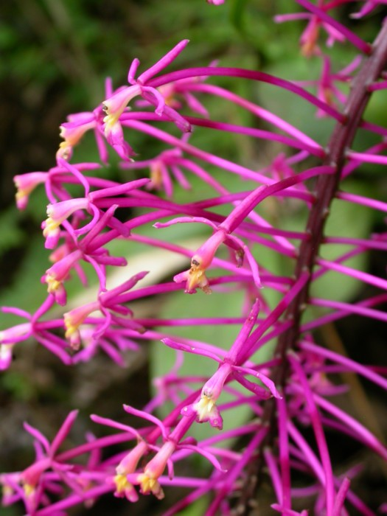
Orchid: Epidendrum possibly syringothyrsus

Continuing our descent towards Canchayoc, we stopped when a feeding flock of birds crosses the road. These mixed-species flocks are typical of tropical forests. The largest can consist of more than 150 individuals of more than 60 different species!! One does not know any more where to look, and in this flock we identified: 2 Marcapata Spinetail, 3 Pearled Treerunner, 2 White-throated Tyrannulet, at least 10 Spectacled Whitestart, 3 Citrine Warbler, 5 White-browed Conebill, 10 Superciliared Hemispingus, 1 Oleaginous Hemispingus, 2 Rufous-chested Tanager, 2 Black-throated Flowerpiercer. Unfortunately a downpour of several hours obliged us to turn back and to return in Cusco... with the desire for returning another day to these wonderul forests!
The following day, we returned to Lima by plane.

Bird species list :

This list does not have anything exceptional, but the goal of this circuit was not to see the most possible species in two weeks! The first three columns indicate the species observed on November 27 (pelagic), November 28 (Lomas de Lachay and Ventanillas) and during Southern Circuit (of Nov. 29 at Dec. 11). The End column indicates the species considered as "endemic" by BirdLife International (total range lower than 50.000 km²). The Men column indicates the species considered as threatened by BirdLife (the various statutes are: end = endangered, vul = vulnerable, nt = near threatened).
Some subspecies are regarded as possible species by certain authors. In this case, the name of species in the
first column is put between brackets.

 |  | 27 nov. | 28 nov. | S. Circuit | End | Men
SPHENISCIDAE
Spheniscus humboldti | Humboldt Penguin | x |  | x |  | vul
PODICIPEDIDAE
Podilymbus podiceps | Pied-billed Grebe |  | x | x
Rollandia rolland | White-tufted Grebe |  | x | x
Rollandia microptera | Titicaca Flightless Grebe |  |  | x | E
Podiceps major | Great Grebe |  |  | x
DIOMEDEIDAE
Diomedea irrorata | Waved Albatross | x |  |  |  | vul
PROCELLARIIDAE
Procellaria aequinoctialis | White-chinned Petrel | x |  |  |  | vul
Puffinus creatopus | Pink-footed Shearwater | x |  |  |  | vul
Puffinus griseus | Sooty Shearwater | x
HYDROBATIDAE
Oceanodroma tethys | Wedge-rumped Storm-petrel | x
Oceanodroma hornbyi | Ringed Storm-petrel | x
Oceandroma melania | Black Storm-petrel | x
Oceanites gracilis | White-vented Storm-Petrel | x
Oceanites oceanicus | Wilson's Storm-petrel | x
PELECANOIDAE
Pelecanoides garnotii | Peruvian Diving-petrel | x |  |  |  | end
PELECANIDAE
Pelecanus (occidentalis) thagus | Peruvian Pelican | x |  | x
SULIDAE
Sula variegata | Peruvian Booby | x |  | x
PHALACROCORACIDAE
Phalacrocorax olivaceus | Neotropic Cormorant | x | x | x
Phalacrocorax bougainvillii | Guanay Cormorant | x |  | x
Phalacrocorax gaimardi | Red-legged Cormorant | x |  | x |  | nt
ARDEIDAE
Egretta alba | Great White Egret |  | x | x
Egretta caerulea | Little Blue Heron |  | x | x
Egretta thula | Snowy Egret |  | x | x
Bubulcus ibis | Cattle Egret |  | x | x
Butorides striatus | Striated Heron |  | x | x
Nycticorax nycticorax | Black-crowned Night-heron |  | x | x
Tigrisoma fasciatum | Fasciated Tiger-heron |  |  | x
Ixobrychus exilis | Least Bittern |  | x
THRESKIORNITHIDAE
Plegadis ridgwayi | Puna Ibis |  | x | x
PHŒNICOPTERIDAE
Phoenicopterus chilensis | Chilean Flamingo |  |  | x |  | nt
ANATIDAE
Chloephaga melanoptera | Andean Goose |  |  | x
Merganetta armata | Torrent Duck |  |  | x
Anas flavirostris | Speckled Teal |  |  | x
Anas specularioides | Crested Duck |  |  | x
Anas georgica | Yellow-billed Pintail |  |  | x
Anas bahamensis | White-cheeked Pintail |  | x | x
Anas puna | Puna Teal |  |  | x
Anas cyanoptera | Cinnamon Teal |  |  | x
Oxyura (jamaicensis) ferruginea | Andean Ruddy-duck |  |  | x
CATHARTIDAE
Cathartes aura | Turkey Vulture | x |  | x
Coragyps atratus | Black Vulture |  | x | x
Vultur gryphus | Andean Condor |  |  | x |  | nt
PANDIONIDAE
Pandion haliaetus | Osprey |  |  | x
ACCIPITRIDAE
Parabuteo unicinctus | Harri's Hawk |  |  | x
Geranoaetus melonoleucus | Black-chested Buzzard-eagle |  | x | x
Buteo magnirostris | Roadside Hawk |  |  | x
Buteo polyosoma | Red-backed Hawk |  | x | x
Buteo poecilochrous | Puna Hawk |  |  | x
FALCONIDAE
Phalcoboenus megalopterus | Mountain Caracara |  |  | x
Falco sparverius | American Kestrel |  | x | x
Falco femoralis | Aplamado Falcon |  |  | x
Falco peregrinus | Peregrine Falcon | x |  | x
RALLIDAE
Pardirallus sanguinolentus | Plumbeous Rail |  |  | x
Gallinula chloropus | Moorhen |  | x | x
Fulica ardesiaca | Andean Coot |  | x | x
Fulica gigantea | Giant Coot |  |  | x
HAEMATOPODIDAE
Haematopus ater | Blackish Oystercatcher | x |  | x
Haematopus palliatus | American Oystercatcher |  |  | x
RECURVIROSTRIDAE
Himantopus mexicanus | Black-necked Stilt |  | x | x
Himantopus (mexicanus) melanurus | White-backed Stilt |  |  | x
BURHINIDAE
Burhinus superciliaris | Peruvian Thick-knee |  | x
CHARADRIIDAE
Vanellus resplendes | Andean Lapwing |  |  | x
Charadrius semipalmatus | Semipalmated Plover |  |  | x
Charadrius vociferus | Killdeer |  | x | x
Charadrius (alexandrinus) occidentalis | Snowy Plover |  |  | x
Charadrius alticola | Puna Plover |  |  | x
SCOLOPACIDAE
Numenius phaeopus hudsonicus | Hudsonian Whimbrel | x |  | x
Tringa melanoleuca | Greater Yellowlegs |  |  | x
Tringa flavipes | Lesser Yellowlegs |  | x | x
Actitis macularia | Spotted Sandpiper |  | x | x
Arenaria interpres | Ruddy Turnstone | x | x | x
Calidris alba | Sanderling | x |  | x
Calidris pusilla | Semipalmated Sandpiper |  | x | x
Calidris minutilla | Least Sandpiper |  |  | x
Calidris bairdii | Baird's Sandpiper |  |  | x
Phalaropus tricolor | Wilson's Phalarope |  |  | x
Phalaropus fulicarius | Grey Phalarope | x
THINOCORIDAE
Thinocorus orbignyianus | Grey-breasted Seedsnipe |  |  | x
Thinocorus rumicivorus | Least Seedsnipe |  | 5
STERCORARIIDAE
Stercorarius pomarinus | Pomarine Skua | 20
Stercorarius parasiticus | Arctic Skua | 5
Stercorarius longicaudus | Long-tailed Skua | 10
LARIDAE
Larus belcheri | Belcher's Gull | x |  | x
Larus modestus | Grey Gull | x |  | x
Larus dominicanus | Kelp Gull | x |  | x
Larus cirrocephalus | Grey-headed Gull |  | x | x
Larus serranus | Andean Gull |  |  | x
Larus pipixcan | Franklin's Gull | x |  | x
Xema sabini | Sabine's Gull | 20
Creagrus furcatus | Swallow-tailed Gull | 1
STERNIDAE
Sterna elegans | Elegant Tern | x |  |  |  | nt
Sterna sandvicensis | Sandwich Tern |  |  | x
Sterna hirundinacea | South American Tern | 1
Sterna hirundo | Common Tern | x
Sterna lorata | Peruvian Tern | 5 |  |  |  | nt
Chlidonias niger | Black Tern | 1
Larosterna inca | Inca Tern | x
COLUMBIDAE
Columba maculosa | Spot-winged Pigeon |  |  | x
Zenaida auriculata | Eared Dove |  | x | x
Zenaida meloda | Pacific Dove |  | x | x
Columbina cruziana | Croaking Ground-dove |  | x | x
Metriopelia ceciliae | Bare-faced Ground-dove |  | 2 | x
Metriopelia melanoptera | Black-winged Ground-dove |  |  | x
Metriopelia aymara | Golden-spotted Ground-dove |  |  | x
Leptotila verreauxi | White-tipped Dove |  |  | x
PSITTACIDAE
Aratinga wagleri | Scarlet-fronted Parakeet |  |  | x
Aratinga mitrata | Mitred Parakeet |  |  | x
Psilopsiagon aurifrons | Mountain Parakeet |  | +100 | x
CUCULIDAE
Crotophaga sulcirostris | Groove-billed Ani |  | 4 | x
STRIGIDAE
Athene cunicularia | Burrowing Owl |  | 6 | x
CAPRIMULGIDAE
Chordeiles acutipennis | Lesser Nighthawk |  |  | x
APODIDAE
Streptoprocne zonaris | White-collared Swift |  |  | x
Chaetura pelagica | Chimney Swift |  |  | x
Aeronautes andecolus | Andean Swift |  |  | x
TROCHILIDAE
Colibri coruscans | Sparkling Violet-ear |  | 2 | x
Amazilia amazilia | Amazilia Hummingbird |  |  | x
Boissonneaua matthewsii | Chesnut-breasted Coronet |  |  | x
Aglaectis castelnaudii | White-tufted Sunbeam |  |  | x | E
Oreotrochilus estella | Andean Hillstar |  |  | x
Pterophanes cyanopterus | Great Sapphirewing |  |  | x
Patagona gigas | Giant Hummingbird |  |  | x
Ocreatus underwoodii | Booted Racquet-tail |  |  | x
Lesbia nuna | Green-tailed Trainbearer |  |  | x
Metallura aeneocauda | Scaled Metaltail |  |  | x | E
Metallura phoebe | Black Metaltail |  |  | x
Aglaiocercus kingi | Long-tailed Sylph |  |  | x
Rhodopis vesper | Oasis Hummingbird |  | x | x
Thaumastura cora | Peruvian Sheartail |  |  | x
Myrtis fanny | Purple-collared Woodstar |  | x
MOMOTIDAE
Momotus aequatorialis | Highland Motmot |  |  | x
PICIDAE
Colaptes rupicola | Andean Flicker |  |  | x
FURNARIIDAE
Geositta cunicularia | Common Miner |  |  | x
Geositta peruviana | Coastal Miner |  | x | x | E
Geositta crassirostris | Thick-billed Miner |  | 1 |  | E
Upucerthia albigula | White-throared Earthcreeper |  |  | x | E
Upucerthia ruficauda | Straight-billed Earthcreeper |  |  | x
Cinclodes fuscus | Bar-winged Cinclodes |  |  | x
Cinclodes taczanowskii | Surf Cinclodes |  |  | x | E
Phleocryptes melanops | Wren-like Rushbird |  | x | x
Leptasthenura striata | Streaked Tit-spinetail |  |  | x
Schizoeaca helleri | Puna Thistletail |  |  | x | E
Cranioleuca marcapatae | Marcapata Spinetail |  |  | x | E
Asthenes pudibunda | Canyon Canastero |  |  | x | E
Asthenes ottonis | Rusty-fronted Canastero |  |  | x | E
Asthenes modesta | Cordilleran Canastero |  |  | x
Asthenes arequipae | Dark-winged Canastero |  |  | x
Margarornis squamiger | Pearled Treerunner |  |  | x
Xenops rutilans | Streaked Xenops |  |  | x
FORMICARIIDAE
Grallaria rufula occabambae | Southern Rufous Antpitta |  |  | x
COTINGIDAE
Ampelion rubrocristatus | Red-crested Cotinga |  |  | x
Rupicola peruviana | Andean Cock-of-the-rock |  |  | x
TYRANNIDAE
Phyllomyias plumbeiceps | Sclater's Tyrannulet |  |  | x
Elaenia albiceps | White-crested Elaenia |  |  | x
Camptostoma (obsoletum) sclateri | Tumbes Beardless-Tyrannulet |  |  | x
Mecocerculus leucophrys | White-throated Tyrannulet |  |  | x
Serpophaga cinerea | Torrent Tyrannulet |  |  | x
Tachuris rubrigastra | Many-colored Rush-tyrant |  | x | x
Sayornis nigricans | Black Phoebe |  |  | x
Pyrocephalus rubinus | Vermilion Flycatcher |  | x | x
Lessonia oreas | Andean Negrito |  |  | x
Ochtoeca rufipectoralis | Rufous-breasted Chat-tyrant |  |  | x
Ochthoeca fumicolor | Brown-backed Chat-tyrant |  |  | x
Ochthoeca oenanthoides | D'Orbigny's Chat-tyrant |  |  | x
Ochthoeca leucophrys | White-browed Chat-tyrant |  |  | x
Agriornis montana | Black-billed Shrike-tyrant |  |  | x
Muscisaxicola junicensis | Puna Ground-tyrant |  |  | x
Muscisaxicola albifrons | White-fronted Ground-tyrant |  |  | x
Muscisaxicola rufivertex | Rufous-napped Ground-tyrant |  |  | x
Muscigralla brevicauda | Short-tailed Field-tyrant |  | x | x
Myiodynastes chrysocephalus | Golden-crowned Flycatcher |  |  | x
Tyrannus melancholicus | Tropical Kingbird |  |  | x
HIRUNDINIDAE
Riparia riparia | Collared Sand Martin |  | 1
Notiochelidon murina | Brown-bellied Swallow |  |  | x
Notiochelidon cyanoleuca | Blue-and-white Swallow |  | x | x
Haplochelidon andecola | Andean Swallow |  |  | x
Hirundo rustica | Barn Swallow |  | 2 | x
CINCLIDAE
Cinclus leucocephalus | White-capped Dipper |  |  | x
TROGLODYTIDAE
Troglodytes aedon | Southern House Wren |  | x | x
MIMIDAE
Mimus longicaudatus | Long-tailed Mockingbird |  |  | x
TURDIDAE
Myadestes ralloides | Andean Solitaire |  |  | x
Catharus ustulatus | Swainson's Thrush |  |  | x
Turdus chiguanco | Chiguanco Thrush |  | x | x
Turdus fuscater | Great Thrush |  |  | x
EMBERIZIDAE
Zonotrichia capensis | Rufous-collared Sparrow |  | x | x
Phrygilus punensis | Peruvian Sierra-finch |  |  | x
Phrygilus fructiceti | Mourning Sierra-finch |  |  | x
Phrygilus unicolor | Plumbeous Sierra-finch |  |  | x
Phrygilus plebejus | Ash-breasted Sierra-finch |  |  | x
Phrygilus alaudinus | Band-tailed Sierra-finch |  |  | x
Diuca speculifera | White-winged Diuca-finch |  |  | x
Xenospingus concolor | Slender-billed Finch |  |  | x | E | vul
Poospiza hispaniolensis | Collared Warbling-finch |  |  | x
Sicalis lutea | Puna Yellow-finch |  |  | x
Sicalis uropygialis | Bright-rumped Yellow-finch |  |  | x
Sicalis olivascens | Greenish Yellow-finch |  |  | x
Sicalis flaveola | Saffron Finch |  |  | x
Sicalis raimondii | Raimondi's Yellow-finch |  |  | x
Volatinia jacarina | Blue-black Grassquit |  |  | x
Sporophila nigricollis | Yellow-bellied Seedeater |  |  | x
Sporophila peruviana | Parrot-billed Seedeater |  |  | x
Sporophila telasco | Chesnut-throated Seedeater |  |  | x
Catamenia analis | Band-tailed Seedeater |  |  | x
Catamenia inornata | Plain-colored Seedeater |  |  | x
CARDINALIDAE
Pheucticus aureoventris | Black-backed Grosbeak |  |  | x
Saltator aurantiirostris | Golden-billed Saltator |  |  | x
Saltator albicollis | Streaked Saltator |  |  | x
THRAUPIDAE
Hemispingus superciliaris | Superciliared Hemispingus |  |  | x
Hemispingus frontalis | Oleaginous Hemispingus |  |  | x
Thlypopsis ornata | Rufous-chested Tanager |  |  | x
Ramphocelus carbo | Silver-beaked Tanager |  |  | x
Thraupis episcopus | Blue-grey Tanager |  |  | x
Thraupis palmarum | Palm Tanager |  |  | x
Thraupis bonariensis | Blue-and-yellow Tanager |  |  | x
Pipraeidea melanonota | Fawn-breasted Tanager |  |  | x
Tangara xanthocephala | Saffron-crowned Tanager |  |  | x
Tangara cyanicollis | Blue-necked Tanager |  |  | x
Tangara viridicollis | Silver-backed Tanager |  |  | x
Dacnis cayana | Blue Dacnis |  |  | x
Diglossa brunneiventris | Black-throated Flower-piercer |  |  | x
Diglossa mystacalis | Moustached Flower-piercer |  |  | x
PARULIDAE
Parula pitiayumi | Tropical Parula |  |  | x
Myioborus miniatus | Slate-throated Redstart |  |  | x
Myioborus melanocephalus | Spectacled Whitestart |  |  | x
Basileuterus luteoviridis | Citrine Warbler |  |  | x
Conirostrum cinereum | Cinereous Conebill |  |  | x
Conirostrum ferrugineiventre | White-browed Conebill |  |  | x
VIREONIDAE
Vireo olivaceus | Red-eyed Vireo |  |  | x
ICTERIDAE
Psarocolius angustifrons | Russet-backed Oropendola |  |  | x
Agelaius thilius | Yellow-winged Blackbird |  |  | x
Sturnella bellicosa | Peruvian Meadowlark |  | x | x
Dives warszewiczi | Scrub Blackbird |  |  | x
Molothrus bonariensis | Shiny Cowbird |  |  | x
FRINGILLIDAE
Carduelis magellanica | Hooded Siskin |  |  | x
Carduelis olivacea | Olivaceous Siskin |  |  | x
Carduelis atrata | Black Siskin |  |  | x
PLOCEIDAE
Passer domesticus | House Sparrow |  |  | x

